|  |  |
| --- | --- |
|  | **Qatar University**  **College of Engineering**  **Department of Computer Science and Engineering** |

Senior Project Report

Drone-based Infrastructure Inspection and data transmission

Group Code: SDP2324_CE_F_22

Project Group Members:

* Fajer Ahmed Robelah – 201902172
* Abeer Mohammed AlMarri - 201104208
* Hila Al-Dosari - 201609925

Supervisor: Dr. Muhammed Moazam Azeem

Co-Supervisor: Dr. Sumaya Al-Maadeed

**Fall 2023 – Spring 2024**

This project report is submitted to the Department of Computer Science and Engineering of Qatar University in partial fulfillment of the requirements of the Senior Project course.

# Declaration

This report has not been submitted for any other degree at this or any other University. It is solely the work of us except where cited in the text or the Acknowledgements page. It describes work carried out by us for the capstone design project. We are aware of the university’s policy on plagiarism and the associated penalties and we declare that this report is the product of our own work.

Student: Fajer Ahmed Robelah



Date: 30/4/2024

Signature:



Student: Abeer Mohammed Al-marri

Date: 30/4/2024



Signature:

Student: Hila Al-Dosari

Date: 30/4/2024

Signature:

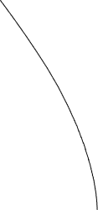

# Abstract

The Drone-based Infrastructure Inspection and Data Transmission extend points to address the required productive and secure review of basic infrastructure such as bridges, power lines, and pipelines [24]. Conventional review strategies regularly require manual labor and can posture security dangers to laborers [20]. In addition, the manual collection of information can be time-consuming and inclined to mistakes[23].

To overcome these challenges, our project proposes the improvement of a drone framework that will revolutionize foundation assessment [21]. The drone will be equipped with sensors and cameras to capture high-resolution pictures and recordings of the infrastructure [24]. These pictures and recordings will be transmitted safely to a central server for advance examination[22].

One of the key goals of our venture is to guarantee the secure transmission of information[21]. We are going to execute encryption algorithms to ensure the privacy and judgment of the transmitted information [23]. Also, verification instruments will be utilized to guarantee that as it were authorized people can get to the collected information [20].

In addition, our project will incorporate automated analysis techniques to manage the gathered data [23]. We identify potential fundamental flaws or anomalies in the evaluated infrastructure by utilizing computer vision and machine learning methods [24]. This will facilitate the prompt identification of possible problems, leading to easy assistance and the avoidance of terrible setbacks [22].

To improve the efficacy and security of infrastructure evaluation, the Drone-based Infrastructure Inspection and Information Transmission extends points in outline [21]. Drones and secure information transfer allow for the expediting of inspection preparation, cost reduction, and improvement of information accuracy [20]. This project has the ability to completely change how basic infrastructure is maintained and evaluated [21].

# Acknowledgment

Our sincere appreciation goes out to Dr. Muhammed Moazam Azeem for his great advice and mentorship during the project's development regarding Drone-based Infrastructure Inspection and Data Transmission. Dr. Moazam's domain knowledge has been crucial in forming the project's conceptual framework and offering insightful advice at every turn.

The success of this initiative may be attributed to his unwavering drive to creating a rich learning environment and his unshakable commitment to excellence. Dr. Moazam's support and helpful criticism have been essential in improving the approach of our study and raising its general caliber.

We genuinely appreciate Dr. Moazam's willingness to share his expertise, which has expanded our knowledge of drone technology and sparked a desire for creative approaches to infrastructure assessment.

Outside of the classroom, we would like to thank our family and friends for their continuous support during this initiative. Their support and empathy have been a never-ending source of inspiration.

Finally, we would want to express our gratitude to Dr. Moazam and everyone else who helped make this initiative a success, whether directly or indirectly. Your assistance and efforts have been invaluable, and we really appreciate the spirit of cooperation that allowed this project to be accomplished.

Table of Contents

Declaration ii

Abstract iii

Acknowledgment iv

List of Figures vii

List of tables viii

1. Introduction and Motivation 9

1.1. Problem statement 9

1.2. Project objectives 9

1.3. Project significance and expected benefits 9

1.4. Analysis of global, economic, environmental, and social impact 10

1.5. Market Research and Business Viability 10

1.6. Justification of the problem as a complex engineering problem 11

2. Background and related work 12

2.1. Background 12

2.2. Related work 12

3. Requirements analysis 13

3.1. Functional requirements 13

3.2. Design constraints 14

3.3. Design standards 16

3.4. Professional Code of Ethics 16

3.5. Assumptions 17

4. Project Plan 17

4.1. Project milestones 17

4.2. Project timeline 17

4.3. Anticipated risks 18

5. Solution design 18

5.1. Solution overview 18

5.2. High level architecture 19

5.3. Design alternatives 19

5.4. Hardware/software used 21

5.5. Hardware design 21

5.6. Software design 22

5.7. New-gained knowledge 22

6. Implementation 23

6.1. New-gained knowledge 23

7. Testing and Evaluation 23

8. Analysis of the impact of the engineered solution 24

9. Conclusion 25

10. Future work 25

11. Student reflections 25

References 27

Appendix A – Culmination of Design Experiences 28

Other Appendices 29

# List of Figures

Figure 0. Diagram illustration drone-based infrastructure inspection process…………..….11

Figure 1. Mission of the inspection of a telecommunication antenna using in that project...22

Figure 2. Construction worker and safety manager indirect interaction through drone technology………………………………………………………………...……………….23

Figure 3. An illustration of the IoPST concept…………………………………………….24

Figure 4.0 Block diagrams for system……………………………………………………..32

Figure 4. System Architecture Block Diagram……………………………………………33

Figure 5. Drone Flight Control Flowchart Diagram……………………………………....35

Figure 6. User Interface and Reporting Flowchart Diagram……………………………...36

Figure 7. ESP32 ……………………………...……………………………………………43

Figure 8. MQ-2 ……………………..…………………………………...…………….….44

Figure 9. TF-Luna ………………...……………….…………………………...……...….45

Figure 10. magnetometer chip …………………………….………………………...…....46

Figure 11. magnetometer chip pin …..………………………………………………...….46

Figure12.Raspberry Pi 4………………………………………………………..……….…47

Figure13.ESP32……………………………………………………………………………48

Figure14. Drone…………………………………………...………………………………48

Figure 15. ESP32 library in Arduino……………………………………….…………..….49

Figure 16. webRTC file transfer……………………………………………………………65

Figure 17. ESP32 pins ……………………………………..…………...………………….68

Figure 18. gas sensor to the ESP32……………………………………..………………….68

Figure 19. LiDAR sensor to the ESP32 …………………………….…..…………………69

##### Figure 20. magnetometer sensor to the ESP32…………………………………………….70

##### Figure 21. Raspberry pi4 with camera……………………………………………………..79

##### Figure 22. Raspberry pi 4 with ESP32 camera config……………………..………………80

Figure 23. SD card………………………………………………………………………….80

##### Figure 24. Drone and all sensor to the ESP32………...……………………………………81

# List of tables

Table 1. Expected benefits and impacts of various contexts………………….…….….….…14

Table 2. Design constraints…………………………………………………….……....…….21

Table 3. Engineering Standards used in the project……………….……………….….….….24

Table 4. Engineering Code of Ethics and Professional Practice………………….…….……25

Table 5. Milestones of the project……………………………………………………...…….27

Table 5.1. project timeline …………………………………………………………...………28

Table 6. Risks…………………………………………………………………………..…….29

Table 7. Design alternatives………………………………………………………….….…...35

Table 8. Design alternatives……………………………………………………………..........39

Table 9. Needed HW……………………………….………….………………….…….……40

Table 10. Needed SW …………………………………………………………….….………42

# Introduction and Motivation

As our society continues to advance technologically, the need for robust and efficient infrastructure becomes increasingly apparent [25] . Infrastructure and pipelines serve as lifelines for communities, making their inspection and maintenance imperative. However, conventional inspection methods often fall short in terms of speed, cost-effectiveness, and accuracy, highlighting the necessity for innovative solutions.

Our project, the Drone-based Infrastructure Inspection and Data Transmission system, is a response to this pressing need [26] . We aim to combine the power of unmanned aerial vehicles (UAVs) with state-of-the-art sensor technology to revolutionize infrastructure inspection. By leveraging drones equipped with advanced sensors and imaging capabilities, we can conduct swift, thorough, and cost-effective assessments of critical infrastructure.

The core technical aspects of our project involve integrating various sensors, including gas sensors, LIDAR (Light Detection and Ranging) technology, and magnetometers, into our drone system [27]. These sensors enable real-time data collection on gas levels, distance measurements, and magnetic fields, providing invaluable insights into potential hazards and structural integrity.

One of the key challenges we address is ensuring the seamless transmission and analysis of the vast amount of data gathered during inspections [28]. To achieve this, our system incorporates robust encryption and authentication protocols, safeguarding sensitive information and ensuring data integrity throughout the transmission process.

In this detailed introduction, we will delve deeper into the technical intricacies of our Drone-based Infrastructure Inspection and Data Transmission system, outlining its design principles, operational workflows, and the innovative technologies driving its functionality. By the end of this report, you will gain a comprehensive understanding of how our project merges cutting-edge technology with meticulous data analysis to enhance infrastructure safety and reliability [29] .

## Problem statement

Infrastructure inspections are crucial but time-consuming and risky for workers. We need a safer, faster, and more accurate way to check bridges, power lines, and pipelines. Traditional methods aren’t efficient enough for today’s needs.

**Technical Challenges**:

* **Drone Framework Development:** Creating a drone framework that’s able of capturing high-resolution pictures and recordings of the infrastructure.
* **Sensor and Camera Integration:** Actualizing progressed sensors and cameras on the drone to guarantee exact information collection.
* **Secure Data Transmission:** Planning a secure information transmission component to secure the privacy and astuteness of the collected information.
* **Real-time Data Processing:** Developing real-time data processing algorithms to analyze sensor data and identify potential issues during flights

**Non-Technical Challenges:**

* **Regulatory Compliance:** Ensuring adherence to regulatory requirements and securing necessary authorizations for drone operations.
* **Public Perception:** Addressing public apprehensions regarding safety and privacy concerns associated with drone utilization.
* **Data Management:** Efficiently overseeing the substantial volume of data generated through drone inspections, ensuring optimal storage, and facilitating effective analysis.
* **Training and Skill Development:** Delivering comprehensive training programs to equip staff with the skills necessary for proficient drone system operation and maintenance.

The project intends to revolutionize infrastructure inspection by offering an effective and secure solution for assessing critical infrastructure by tackling these technical and non-technical obstacles.

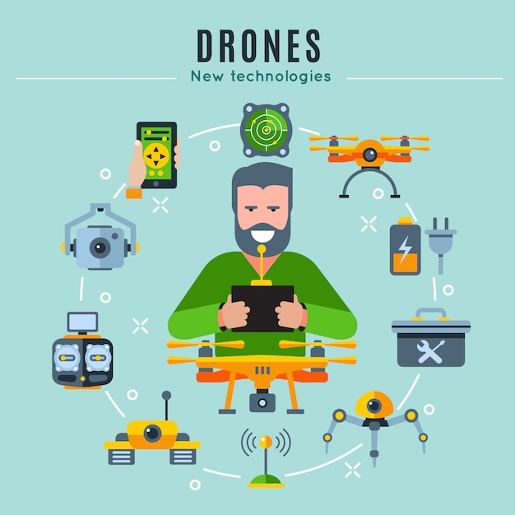

##### Figure 0. Diagram illustration drone-based infrastructure inspection process

## Project objectives

Our project is driven by a set of specific objectives designed to address the challenges and limitations of traditional infrastructure inspection methods. These objectives form the cornerstone of our innovative approach, guiding us toward the development of a comprehensive solution that revolutionizes the way critical infrastructure is assessed and maintained. By articulating clear objectives, we aim to achieve tangible outcomes that enhance the safety, reliability, and efficiency of vital infrastructure systems.

**Project Objectives:**

1. **Integrate advanced sensors like gas sensors, LIDAR, and magnetometers into the drone:**
   * Incorporate gas sensors to detect and monitor gas leaks during flights.
   * Utilize LIDAR technology for creating 3D maps of the infrastructure and measuring distances.
   * Integrate magnetometers to provide accurate magnetic field data for precise mapping.

**2- Implement image processing algorithms for data analysis:**

* Develop algorithms to process high-resolution images and videos captured by the drone.
* Analyze image data to detect structural defects, anomalies, or potential hazards.
* Use computer vision techniques to identify and classify objects of interest during inspections.

**4- Enable real-time data transmission from the drone to base stations:**

* Establish a secure and reliable communication system for transmitting data in real-time.
* Ensure continuous connectivity between the drone and ground stations for seamless data transfer.
* Implement protocols for data compression and efficient transmission to minimize latency

**5- Ensure autonomous navigation capabilities for efficient inspections:**

* Develop autonomous flight algorithms to optimize inspection routes and avoid obstacles.
* Enable the drone to navigate complex environments and follow predefined inspection paths.
* Incorporate obstacle detection and avoidance mechanisms to enhance safety and efficiency.

**6- Provide a user-friendly interface for system operation and data visualization:**

* Design an intuitive control interface for drone operators to monitor and control the inspection process.
* Develop data visualization tools to present inspection results in a clear and actionable format.
* Incorporate interactive features for data analysis, anomaly detection, and decision support.

**Desired Results:**

1. **Accurate and comprehensive infrastructure assessments:**
   * Ensure that the drone system can gather precise data on infrastructure components such as pipelines.
   * Generate detailed inspection reports with accurate measurements, defect detection, and anomaly identification.

**2- Efficient and cost-effective inspection operation:**

* Increase inspection efficiency by reducing the time and resources required for manual inspections.
* Lower inspection costs by leveraging automation, reducing labor expenses, and optimizing resource utilization.

**3- Improve safety for inspectors and infrastructure:**

* Minimize risks to human inspectors by using drones to access hazardous or hard-to-reach areas for inspections.
* Enhance overall safety by detecting potential hazards, structural weaknesses, or maintenance issues early.

**3- Early detection and prevention of infrastructure failures:**

* Identify and address structural defects, equipment malfunctions, or environmental hazards before they escalate into critical failures.
* Implement proactive maintenance strategies based on predictive analytics and inspection data insights.

4**- Increase public trust and regulatory compliance:**

* Build public trust and confidence in infrastructure safety and reliability through transparent and thorough inspections.
* Ensure compliance with industry standards, regulations, and environmental requirements related to infrastructure maintenance and inspections.

**Specific Deliverables:**

1. **Detailed Inspection Reports:**

* Comprehensive reports summarizing inspection findings, including defect locations, severity assessments, and recommended actions.

**2- High-Resolution Images and Videos:**

* Captured media showcasing infrastructure components, defects, and areas of interest for further analysis and documentation

**3- 3D Maps and Diagrams:**

* Generated maps and diagrams depicting infrastructure layouts, defect locations, and spatial relationships for visual clarity and analysis.

**4- Data Analysis Tools and Algorithms:**

* Developed algorithms and software tools for data processing, defect detection, anomaly identification, and predictive analytics.

**5- Risk Assessment and Safety Recommendations:**

* Risk assessment reports highlighting potential safety hazards, structural vulnerabilities, and recommended safety measures.

**6- Regulatory Compliance Documentation:**

* Documentation verifying compliance with regulatory standards, certifications, and operational permits for drone inspections

**7- Training Materials and Manuals:**

* Educational materials, training modules, and user manuals for drone operators, inspectors, and maintenance personnel.

## Project significance and expected benefits

This project is important because it uses a drone system with combination of sensors to solve the oil and gas leakage problem. In terms of safety Its importance is emphasized by the possibility of errors being unpredictable, which is a source of emergency. The introduction of a new approach in drone systems is expected to make a remarkable contribution to industrial practice and research. The complexity of the project comes from the intersection of various technical priorities, such as encrypted data, data analysis and dealing with sensors.

* **Significance of the Project:**

pipelines form the backbone of modern oil and gas industry, and safety and reliability are paramount. Conventional search methods are often labor-intensive, time-consuming, and potentially dangerous for human searchers. Furthermore, manual collection of survey data is prone to errors, Also, it difficult to discover them [15]. The urgent need to examine more efficient, cost-effective and safe pipelines underscores the importance of this work.

**Safety and Reliability Risks:** Improper or infrequent maintenance can lead to unforeseen structural defects or abnormalities, which can lead to catastrophic failures and injuries

**Economic Impact:** Unplanned infrastructure can have significant financial consequences, resulting in disruption, costly repairs and lower productivity

* **Contributions of the project:**

The contributions of this work are relevant to the field of knowledge and technological behavior:

**Academic Contribution:** Combining drone technology, advanced sensors and encryption in infrastructure analysis is an innovative approach and contributes to academic understanding of how emerging technologies can be used to solve engineering problems and it deals with difficulty especially in infrastructure analysis

**Engineering Practice:** The real significance of the project lies in its potential to transform the observational industry. It provides real-world solutions that can enhance the safety, efficiency and accuracy of assessments. This new approach can serve as a model for engineering professionals looking to embrace modern technology in their work [16].

* **Non-particulate features of the project:**

**This project is no small feat for several reasons:**

**Strong integration:** Integrating drones, advanced sensors and encryption into a simple inspection system requires expertise in many areas Existing solutions do not prematurely address this multifaceted challenge.

**Innovation:** The project brings innovation such as secure data transmission through RTC technique, use sensors to serve out needs, real-time analytics and automation. These features go beyond simple extensions to existing routes.

**Personal Career Goals:** This project is driven by a genuine interest in using technology to solve complex real-world problems. Joining this field not only matches career aspirations in engineering but also gives us the opportunity to gain valuable knowledge in project management, interdisciplinary collaboration and engineering it is another in. Successfully completing this project will enhance our knowledge and experience, making us a well-rounded and competitive professional in the field.

## Analysis of global, economic, environmental, and social impact

# Table 1. Expected benefits and impacts of various contexts

|  |  |
| --- | --- |
| Context | Expected benefits and impacts |
| Global | **Infrastructure resilience:** By improving reliability and security in critical infrastructure, our solutions contribute to the resilience of global infrastructure, reducing the impact of natural disasters and problems affect communities around the world.  **Technology transfer:** Our work can serve as a technical model for other regions and countries, facilitating the adoption of advanced project management techniques worldwide. This encourages the transfer of knowledge and technology across borders. |
| Economic | **Cost savings:** The use of drone-based infrastructure monitoring is expected to result in significant cost savings for various stakeholders including governments, utilities and business owners This includes some include reducing labor costs, reducing downtime and preventing costly emergency repairs [17].  **Operations:** While automation may reduce the need for some manual processes, the project will create opportunities for businesses skilled in drone operations and data analysis which can contribute to communities and national employment results.  **Competitiveness:** Countries that adopt advanced infrastructure management technologies gain a competitive advantage by increasing infrastructure reliability. This can attract investment, boost economic growth and improve overall economic competitiveness.  **Manufacturing:** Building and maintaining drone-based surveillance systems can stimulate economic growth in technology. This could lead to employment, investment diversification and possible export opportunities. |
| Environmental | **Reduced pollution**: The project can reduce the environmental impact by reducing the pollution of gas and oil leakage.  **Safety improvements:** The automation of hazardous tasks increases worker safety and reduces the environmental and social impacts of workplace accidents, injuries and related environmental hazards on. |
| Societal | **Enhanced Safety:** Faster fault detection and improved reliability of controls directly contribute to the safety and well-being of communities. This reduces the risk of infrastructure failure, potential human injury and death.  **Public confidence:** Addressing security and privacy concerns associated with drone technology builds public confidence in its use for basic research. This increased recognition and support can have a positive impact on community relations.  **Community resilience:** Reliable infrastructure supports community resilience by ensuring access to essential services in an emergency. This reduces harm and enhances overall community preparedness.  **Skills Development:** Training programs in drone operation and maintenance provide individuals with the opportunity to gain valuable skills in emerging technological areas. This can lead to growth and career advancement, which leads to social development. |

## Market Research and Business Viability

Our research explores some businesses that are thriving in the ever-changing industry of resource management driven by a growing need for innovative solutions. The global market worth billions include industries including pollutions management, utilities and government engineering. Our business seeks to establish a strong and long-lasting position in the cutthroat infrastructure monitoring industry by offering customized pricing structures and comprehensive market penetration strategies.

**Market Research and Business Viability:**

**Market Need and Size:**

The market need for comprehensive infrastructure management solutions is high. Aging infrastructure comes with constant demands that require regular maintenance and inspection. The size of the market is important, as it encompasses various sectors such as civil engineering, utilities, transportation, and so on. The global infrastructure monitoring market is estimated to be worth billions of dollars, with huge growth potential driven by security and efficiency concerns.

**Target Customers and Demographics:**

**Government Agencies:** Federal, state, and local government agencies that administer public services.

**Utility:** gas, oil and utilities that want an efficient way to manage their extensive networks.

**Engineering firms:** Firms involved in civil engineering

**Industry:** Manufacturers and industries with complex critical infrastructure.

**Private Owners:** Owners of private projects such as pipelines and oil industries. Demographics vary, but decision-makers typically include engineers, project managers and product managers.

**Competing Products:**

Existing solutions include manual tracking, ground-based sensors and manned aircraft inspection. However, our solution differs in the following way.

**Automation:** Unlike manual analysis, our solution automates data collection and analysis, reducing labor costs and improving accuracy.

**Aerial advantage:** Drones offer a unique aerial perspective that ground-based methods cannot.

**Real-time analysis:** Machine learning integration enables real-time fault detection.

**Data security:** Strong encryption and authentication mechanisms ensure secure data transmission, addressing privacy concerns.

**Features of the novel:**

**Integrating advanced technologies**: Combining drones, sensors, encryption into an integrated solution.

**Real-time analytics:** Instant defect detection for efficient remediation.

**Enhanced Safety:** Reduces human exposure to hazardous environments.

**Pricing policy:**

Pricing will be based on specific customer requirements, taking into account factors such as the scope, complexity and frequency of inspections. Pricing models may include upfront hardware costs, software license fees, and ongoing maintenance and support subscriptions.

**Launching the product:**

**Product Development:** Completion of hardware and software components, ensuring robustness, accuracy and reliability.

**Compliance:** Obtain all necessary approvals and permits to operate the drone, ensuring compliance.

**Marketing and Sales:** Developing a marketing strategy, targeting key businesses, and establishing a sales team to reach potential customers.

**Training:** Provide comprehensive training programs for users, operators and maintenance personnel.

**Support and Maintenance:** Establish an efficient support and maintenance team to respond to customer needs quickly.

**Collaboration:** Collaborate with drone manufacturers, sensor providers and software developers to optimize production.

**Scaling:** Expand product offerings and market reach based on feedback and demand.

By meeting market needs, differentiating through innovation, and offering a competitive pricing strategy, the drone-based infrastructure inspection and data transmission project aims to establish itself as a viable and sustainable business in the infrastructure analysis market.

## Justification of the problem as a complex engineering problem

One of the main challenges in our work is navigating the competing demands, where the demand for multi-feature systems is the need for cost-effective solutions contradict Multiple components and subsystems such as the drone itself, sensors, data transfer methods and analytical tools add to the complexity. It also affects technology, and the collaboration of stakeholders. The project needs a strong assessment in terms of socio-economic change because it provides technical solutions with complex ramifications. A project requires the highest technical requirements to ensure system safety and reliability due to the direct impact on public safety, economic stability and environmental protection

**Conflicting needs:** Balancing conflicting needs is the main challenge. The need for cost-effective solutions clashes with the desire for feature-rich systems. For example, building a drone-based surveillance system that is cost-effective and capable of providing comprehensive data presents an obvious conflict Advanced features and touch sensors about to keep the data accurate can increase costs, making it harder to balance [18].

**Multiple components or subsystems:** The program involves several interrelated components and subsystems. The drone itself, its sensing devices, data communication systems, and data analysis tools are all unique subsystems. Managing the integration and communication of these components, ensuring smooth operation, and addressing potential failure points represent challenging system engineering challenges.

**Technical solution with complex specifications:** The project seeks to provide a technical solution to a real-world problem. However, the absence of a clear and straightforward solution is evident due to multifaceted constraints and requirements. The adoption of drone-based infrastructure has broad implications, including social applications, budget implementation, and impacts at national, regional and global levels in a critical and systematic way to evaluate the social and economic implications of solutions to these challenges, as well as aspects. The problems should be investigated

**Important practical outcome:** Research measures directly affect public safety, economic stability, and environmental protection. Failure of infrastructure can be catastrophic. The project therefore has significant real-world implications and requires the highest engineering practices to ensure the system is safe and reliable.

# Background and related work

## Background

Our project is playing an important role in reducing the problems comes from oil and gas leakage using drones. The drone is connected with 3 sensors, gas, LDIAR and magnetometer sensor that can detect any gas or oil emitting from pipelines underearth and it specifies the location of them. Also, the drone has an ESP32 camera that can take photo or videos for the infrastructure to show brief image about the leakage. Then this information getting from the drone and send it by RTC transmission technique [19] that gives secure and successful data transfer. The sensors selected for the following:

* Gas sensor: Can be used to measure or detect LPG, Alcohol, Propane, Hydrogen, CO and even methane. When it detected a notification appears.
* LDIAR sensor: to detect the leakage and give the distance of how far it is.
* Magnetometer sensor: show the location of the leakage by giving the 3-axis and heading, after that we can produce 3D image analysis about the leakage place.

This project using the RTC transmission to transfer the files within the same system which gives more secure data.

## Related work

* Accurate data collection is essential to detect possible design deficiencies or anomalies in critical systems [1]. A key challenge for monitoring projects is to ensure reliable data with high resolution. In addition, capturing high-quality 3D images can go a long way in overcoming this challenge. Were in this project they use some mathematical equations that helps in producing 3D images with drone camera.

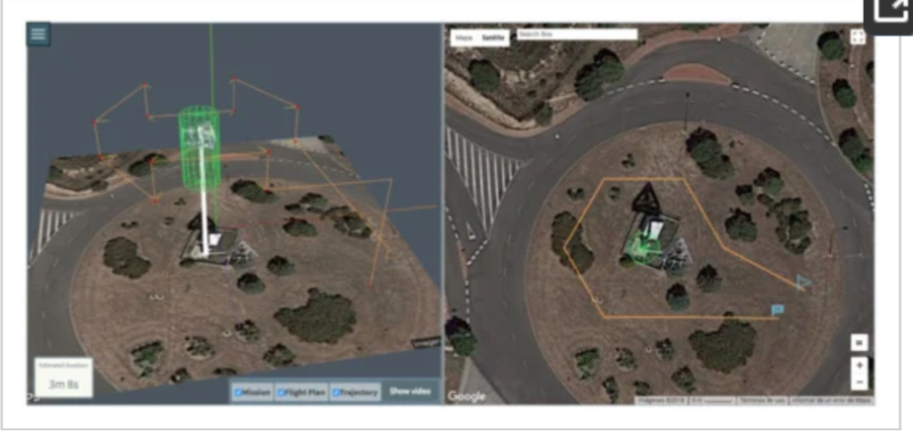

##### **Figure 1.** Mission of the inspection of a telecommunication antenna using in that project.

Also this project use drone to have 3D images to serve the infrastructure [3].

* Traditional inspection methods rely heavily on manual processes, with human inspectors physically inspecting the buildings [2]. This approach is inherently limited, as it introduces the possibility of human error and exposes researchers to safety risks, especially when working in hazardous environments To address these challenges We are using drones in other ways use to identify potential hazards However, the adoption of drones for infrastructure inspections raises security, privacy and public opinion concerns. It is important to address these concerns and actively work towards reliability as a key consideration in the implementation of this technology. While in this project use drone CNN to analyze the infrastructure without any human inspectors, like our project which achieve this.
* The usefulness of drones for the detection of toxic gases and metals is a way of pre-empting potential damage [4]. This approach helps to protect the environment and promote a higher standard of living. They use proposed Gas Sensing System (GSS) while we use a gas sensor which detect many gases.
* in this project they focus on gas from coal fire while we aspect from our sensor that it detects many gases, methane and others [7].
* the use of automation, combined with machine learning and computer vision, offers a promising approach to improve the analysis of collected data If this technology is to be successfully integrated into infrastructure monitoring, it requires special knowledge [5]. Furthermore, the hiring of drones for this purpose raises concerns about security, privacy and public opinion. It is important to address these fears and prioritize building trust in the process.
* Complying with local and national regulations, as well as obtaining the necessary permits for drone operations, is an important part of infrastructure management and this aspect is of utmost importance to us. Additionally, ensuring an efficient inspection process is important to reduce downtime and administrative costs [6]. Striking the right balance between efficiency and maintaining high data quality is very challenging, and often requires flexibility. Meeting this challenge is expected to increase the demand for drones.
* By increasing the reliability and security of critical infrastructure, drones actively enhance the resilience of global infrastructure, reducing the effects of natural disasters and disruptions so and, not only improve worker safety but also reduce environmental and social impacts associated with workplace accidents, injuries and related environmental hazards [8].

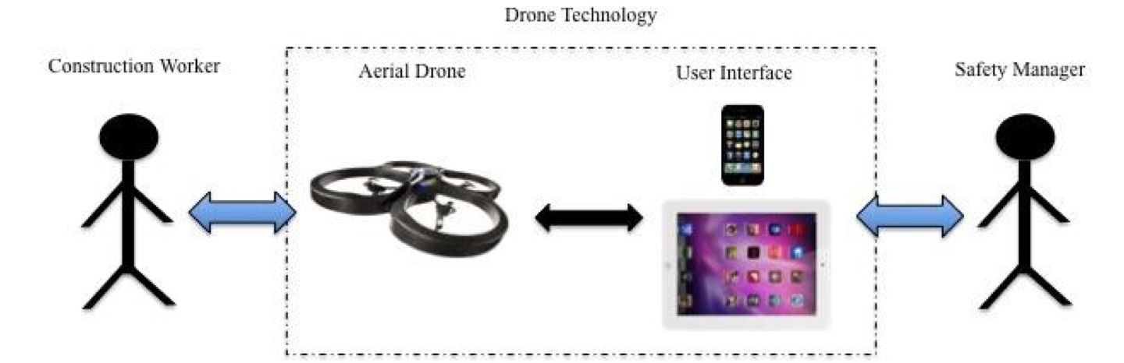

##### **Figure 2.** Construction worker and safety manager indirect interaction through drone technology

this project also focus on safety and how to use drone in emergency by taking about the oPST [9]. The Internet of public safety things (IoPST) refers to wearable things for first responders that are used for public safety and are connected via the Internet, such as cameras, sensors, and drones. This what our project wants to achieve.

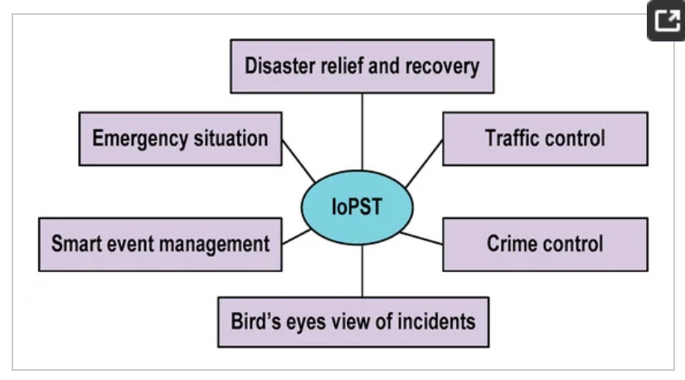

##### **Figure 3..** An illustration of the IoPST concept.

* Drones have been deployed in disaster areas to assess damage, deliver supplies and coordinate humanitarian aid [10]. Their use in such contexts can be politically sensitive, requiring cooperation and cooperation between states and organizations. As drone technology continues to evolve, political leaders and policymakers wrestle with developing laws and policies that address the ethical, legal and security challenges posed by the use of drones in politics.

**Key Similarities and Differences**

To provide a concise overview of the key similarities and differences between our project and previous approaches, we summarize them in the following table:

|  |  |  |
| --- | --- | --- |
| **Aspect** | **Previous Approaches** | **Our Project** |
| Data Collection Sensors | Basic cameras and sensors | Advanced sensors and high-resolution cameras |
| Data Transmission | Limited focus on security | Emphasis on secure data transmission with encryption |
| Data Analysis | Limited automated analysis | Integration of data analysis |
| Public Concerns | Limited consideration | Proactive addressing of safety and privacy concerns |

**Project Distinctions**

Our work stands out by combining advanced sensor technology, secure data communications and automated data analytics. This comprehensive approach is expected to significantly increase the scalability, accuracy, and security of monitoring services over previous efforts Although previous work provided valuable insights, our work the aim is to overcome their limitations by addressing all modern industry research needs.

# Requirements analysis

The framework should collect high-quality data from sensors and imaging technologies, collect data from various infrastructure assets, and process it to extract relevant information· It should generate reports and visualizations, store the data in a secure database, and transfer it to authorized users securely· The framework should be able to integrate with existing infrastructure management systems and support various communication protocols· It should perform efficiently, operate in limited bandwidth, and be compliant with data security regulations· It should be user-friendly, scalable, cost-effective, and compatible with various hardware and software platforms· The framework should also be easy to maintain and update, compatible with various hardware and software platforms, and supported by a knowledgeable vendor.

## Functional requirements

Strong data processing, data gathering, and information transfer capabilities are essential to the success of our infrastructure inspection architecture· The framework needs to fulfill strict criteria and capture high-quality data at particular rates and coverage while addressing various quality aspects· Accurate analysis and real-time data processing are essential for producing reports quickly and with thorough visuals· Secure and dependable data transmission within a predetermined timeframe is necessary for information sharing· Performance, security, usability, scalability, cost-effectiveness, and maintainability are the targeted quality features that characterize the efficacy, affordability, flexibility, and durability of the framework in meeting critical infrastructure assessment demands.

Data Collection:

* Data Acquisition Rate: The framework should be able to collect data from various sensors and imaging technologies at a rate of at least 100 frames per second for high-resolution video and 1000 points per second for LiDAR data.
* Data Coverage: The framework should be able to collect data from a minimum of 95% of the designated infrastructure asset within a single flight.
* Data Quality: The collected data should meet the following quality standards:
* Video: Image resolution of at least 1080p (1920x1080 pixels) with minimal distortion and blur.
* LiDAR: Point cloud density of at least 10 points per square meter with a minimum accuracy of 5 centimeters.

Data Processing:

* Data Processing Speed: The framework should be able to process the collected data in real-time to generate preliminary assessment results within 30 minutes of data collection.
* Data Analysis Accuracy: The framework’s data analysis algorithms should be able to accurately identify and classify structural defects, damage, and asset condition with a minimum accuracy of 90%.
* Report Generation: The framework should be able to automatically generate comprehensive reports summarizing the collected data, extracted information, and assessment results, including detailed visualizations and annotations.

Information Transfer:

* Secure Data Transmission: The framework should employ strong encryption algorithms, such as AES-256, to protect sensitive data during transmission.
* Data Transmission Reliability: The framework should achieve a data transmission success rate of at least 99.9% under various network conditions.
* Data Delivery Speed: The framework should transfer the collected data and extracted information to authorized users within 1 hour of data collection.

Desired Quality Attributes:

Performance:

* Data Collection Time: The framework should be able to complete a comprehensive assessment of a typical infrastructure asset within 60 minutes.
* Data Processing Latency: The framework should process the collected data with a latency of no more than 1 second per frame for video and 5 seconds per scan for LiDAR data.
* Report Generation Time: The framework should generate a comprehensive assessment report within 10 minutes of completing data processing.

Security:

* Data Encryption Strength: The encryption algorithms used should withstand known cryptanalysis attacks with a minimum computational complexity of 2^128 operations.
* Data Access Control: The framework should implement a multi-level access control mechanism that restricts access to sensitive data based on user roles and authorizations.
* Data Breach Detection: The framework should incorporate intrusion detection and prevention systems to monitor and prevent unauthorized access attempts.

Usability:

* User Interface Simplicity: The framework’s user interface should be intuitive, easy to navigate, and require minimal technical expertise to operate.
* Comprehensive User Documentation: The framework should provide detailed and easy-to-understand user manuals, tutorials, and online help resources.
* Contextual Help System: The framework should provide a context-aware help system that offers real-time guidance and assistance to users.

Scalability:

* Sensor Integration: The framework should be able to accommodate the integration of new sensors and imaging technologies without requiring significant modifications.
* Data Processing Scalability: The framework’s data processing algorithms should be scalable to handle increasing data volumes and processing demands.
* Deployment Scalability: The framework should be deployable on a wide range of hardware configurations, from small-scale single-drone operations to large-scale multi-drone fleets.

Cost-Effectiveness:

* Initial Acquisition Cost: The framework’s initial acquisition cost should be competitive with traditional infrastructure assessment methods.
* Operational Cost: The framework’s operational cost, including drone maintenance, sensor calibration, and software updates, should be lower than or equivalent to traditional methods.
* Return on Investment: The framework should provide a clear return on investment by reducing the time and cost of infrastructure assessments, leading to improved asset management and reduced maintenance expenses.

Maintainability:

* Software Updates: The framework should provide regular software updates to address bugs, enhance [[11]](https://www.scribd.com/document/132388981/10-1-1-99-5649).

## Design constraints

Our approach for assessing infrastructure navigates technical limitations, necessitating the use of drones with certain flying characteristics and sensor integrations· It strikes a balance between economic factors, giving affordability, cost-effectiveness, and controllable maintenance expenses priority· Environmental restrictions deal with electromagnetic interference, noise levels, and the overall influence on the environment· Social restrictions emphasize community involvement, privacy protection, and public approval· Human rights must be respected, justice must be served, and openness must be maintained· Constraints related to health and safety necessitate following safety laws, having strong data security, and following occupational health standards· For our infrastructure assessment approach to be deployed responsibly and effectively, it is imperative that we navigate these complex restrictions·

Technical Constraints:

* Drone Flight Capabilities: The drones used in the framework must have sufficient flight time, payload capacity, and sensor capabilities to effectively collect data from the infrastructure assets of interest.
* Sensor Compatibility and Integration: The framework must be able to integrate and utilize a variety of sensors, including cameras, LiDAR, to achieve the desired data quality and coverage.
* Data Processing and Analysis: The framework’s data processing algorithms must be efficient, accurate, and scalable to handle the large volumes of data collected from infrastructure assessments.

Economic Constraints:

* Cost-Effectiveness: The framework’s development, deployment, and operation costs should be competitive with traditional infrastructure assessment methods to ensure a positive return on investment.
* Hardware and Software Affordability: The hardware and software components of the framework should be affordable for a wide range of organizations, including municipalities, engineering firms, and infrastructure asset owners.
* Maintenance and Upkeep Costs: The ongoing maintenance and upkeep costs of the drones, sensors, and software should be manageable and not significantly impact the overall cost-effectiveness of the framework.

Environmental Constraints:

* Noise Pollution: The drones used in the framework should operate at minimal noise levels to minimize disturbance to residents and wildlife in the assessment areas.
* Electromagnetic Interference: The drones and sensors should comply with electromagnetic interference regulations to avoid disrupting other electronic devices and operations.
* Impact on Ecosystem and Wildlife: The framework’s operations should not cause harm to the environment or disrupt the natural habitats of wildlife.

Social Constraints:

* Public Acceptance: The framework’s deployment should be accompanied by public awareness campaigns to inform communities about the benefits and safety measures associated with drone-based infrastructure assessments.
* Privacy Concerns: The framework must adhere to strict data privacy regulations to protect sensitive information collected from infrastructure assessments.
* Community Engagement: The framework’s implementation should involve community engagement to address concerns and ensure that the technology is used in a responsible and respectful manner.

Ethical Constraints:

* Transparency and Accountability: The framework’s data collection, processing, and analysis methods should be transparent and accountable to ensure that the information is used ethically and responsibly.
* Non-discrimination and Fairness: The framework’s algorithms and decision-making processes should be free from bias and discrimination to ensure fair and equitable infrastructure assessments.
* Respect for Human Rights: The framework’s operations should not violate or infringe upon the human rights of individuals or communities.

Health and Safety Constraints:

* Drone Safety: The drones used in the framework must meet all applicable safety regulations and guidelines to minimize the risk of accidents or injuries.
* Data Security and Privacy: The framework must employ robust data security measures to protect sensitive information from unauthorized access, breaches, or misuse.
* Occupational Health and Safety: The framework’s operations must adhere to occupational health and safety regulations to protect the well-being of personnel involved in data collection, processing, and analysis [[11]](https://www.scribd.com/document/132388981/10-1-1-99-5649).

# Table 2. Design constraints

|  |  |  |  |  |
| --- | --- | --- | --- | --- |
| Constraint | Type (Technical/ Socio-Economical) | Relevance to the Project | Evaluation Plan | Success Criteria |
| Drone Flight Capabilities | Technical | Ability to effectively collect data from infrastructure assets | Conduct flight tests in various environments and assess drone performance | Drone can achieve sufficient flight time, payload capacity, and sensor capabilities |
| Sensor Compatibility and Integration | Technical | Ability to utilize a variety of sensors for data collection | Evaluate sensor compatibility, data integration, and image quality | Sensors can be seamlessly integrated with the framework and produce high-quality data |
| Data Processing and Analysis | Technical | Efficient, accurate, and scalable data processing algorithms | Develop and test data processing algorithms to assess performance and accuracy | Algorithms can handle large data volumes, accurately identify defects, and generate comprehensive reports |
| Cost-Effectiveness | Socio-Economical | Competitive cost compared to traditional methods | Conduct cost-benefit analysis and compare with alternative approaches | Framework’s cost-effectiveness justifies its adoption |
| Hardware and Software Affordability | Socio-Economical | Accessibility to a wide range of organizations | Assess hardware and software costs and identify affordable options | Framework components are within the reach of municipalities, engineering firms, and asset owners |
| Maintenance and Upkeep Costs | Socio-Economical | Manageable ongoing maintenance expenses | Track maintenance costs and compare to traditional methods | Maintenance costs do not significantly impact the overall cost-effectiveness |
| Noise Pollution | Environmental | Minimizing noise disturbance to residents and wildlife | Conduct noise level tests and implement noise reduction strategies | Drone operations generate minimal noise levels |
| Electromagnetic Interference | Environmental | Adherence to electromagnetic interference regulations | Test for electromagnetic interference and ensure compliance | Framework operations do not disrupt other electronic devices |
| Impact on Ecosystem and Wildlife | Environmental | Minimizing environmental impact and wildlife disruption | Conduct environmental impact assessments and implement mitigation measures | Framework operations do not harm the environment or disrupt wildlife |
| Public Acceptance | Social | Addressing public concerns and promoting acceptance | Conduct public awareness campaigns and engage with communities | Public perception of drone-based assessments is positive and supportive |
| Privacy Concerns | Social | Adherence to data privacy regulations | Conduct data privacy audits and ensure compliance with regulations | Framework protects sensitive information and complies with privacy laws |
| Community Engagement | Social | Involving communities in the framework’s implementation | Conduct community engagement meetings and address concerns | Communities are informed, engaged, and supportive of the framework |
| Transparency and Accountability | Ethical | Transparent data collection, processing, and analysis methods | Implement data governance policies and conduct audits | Data collection, processing, and analysis are transparent and accountable |
| Non-discrimination and Fairness | Ethical | Bias-free algorithms and decision-making processes | Test algorithms for bias and implement fairness measures | Framework’s algorithms and decisions are fair and equitable |
| Respect for Human Rights | Ethical | Operations that do not violate or infringe upon human rights | Conduct human rights impact assessments and implement mitigation measures | Framework operations respect the human rights of individuals and communities |
| Drone Safety | Health and Safety | Compliance with safety regulations to minimize accident risks | Conduct drone safety audits and implement safety protocols | Drone operations adhere to all applicable safety regulations |
| Data Security and Privacy | Health and Safety | Robust data security measures to protect sensitive information | Implement data encryption, access controls, and intrusion prevention systems | Sensitive information is protected from unauthorized access, breaches, or misuse |
| Occupational Health and Safety | Health and Safety | Adherence to occupational health and safety regulations | Conduct occupational health and safety audits and implement training programs | Personnel involved in data collection, processing, and analysis are protected from health and safety risks |

## Design standards

# Table 3. Engineering Standards used in the project

|  |  |
| --- | --- |
| Standard | Relevance to the Project |
| Technical Standards: |  |
| Drone flight regulations | Ensure safe and compliant drone operation |
| Sensor calibration and accuracy standards | Maintain data quality and accuracy |
| Data processing and analysis standards | Ensure data integrity and reliability |
| Socio-Economic Standards: |  |
| Cost-benefit analysis guidelines | Evaluate the economic feasibility of the project |
| Public procurement standards | Ensure fair and transparent acquisition of equipment and services |
| Community engagement frameworks | Foster effective communication and collaboration with communities |
| Ethical Standards: |  |
| Transparency and accountability guidelines | Promote transparency in data collection, processing, and analysis |
| Non-discrimination and fairness principles | Ensure bias-free algorithms and decision-making processes |
| Health and Safety Standards: |  |
| Drone safety regulations | Ensure safe drone operation and minimize accident risks |
| Data security standards | Protect sensitive information from unauthorized access, breaches, or misuse |
| Occupational health and safety standards | Protect the well-being of personnel involved in data collection, processing, and analysis |

## Professional Code of Ethics

# Table 4. Engineering Code of Ethics and Professional Practice

|  |  |  |
| --- | --- | --- |
| Sec. No. | Code | Usage and Practice Addressing an Identified Issue |
| ACM Engineering Code of Ethics and Professional Practice |  |  |
| 1.1 | Public | Prioritize the public interest in computing decisions, actions, and products. |
| 1.2 | Client and Employer | Act responsibly in the interests of clients and employers while maintaining professional independence. |
| 1.3 | Honesty and Trustworthiness | Be honest and trustworthy in all professional activities. |
| 1.4 | Competence | Maintain professional competence and strive to improve professional skills. |
| 1.5 | Moral and Ethical Principles | Consider moral and ethical implications of professional work. |
| IEEE-CS/ACM Software Engineering Code of Ethics and Professional Practice |  |  |
| 2.1 | Public | Act consistently with the public interest. |
| 2.2 | Client and Employer | Act in a manner that is in the best interests of their client and employer, consistent with the public interest. |
| 2.3 | Product | Ensure that their products and related modifications meet the highest professional standards possible. |
| 2.4 | Judgment | Maintain integrity and independence in their professional judgment. |
| 2.5 | Management | Manage personnel and resources responsibly. |
| 2.6 | Colleagues | Be fair to and supportive of their colleagues. |
| 2.7 | Self | Participate in lifelong learning regarding the practice of their profession and promote an ethical approach to the practice of the profession. |

## Assumptions

The paragraph lists a number of assumptions about the expected advancements in drone technology· Improvements in data transfer, high-resolution sensors, and longer flying range are anticipated· It is anticipated that sensor integration—which includes cameras, gas, Magnetometer and LiDAR—will improve accurate fault identification and comprehensive data collecting· The development of data processing algorithms, which allow for real-time analysis, accurate fault classification, and the compilation of thorough reports, is also predicated on assumptions· Socioeconomic expectations include more public acceptability, improved economic viability, and the availability of trained labor· Environmental presumptions center on reducing impact, following rules, and carrying out efficient mitigation strategies· Accountability, privacy protection, community involvement, fairness, openness, and respect for individual autonomy are given top priority in social and ethical issues.

Technical assumptions:

* Drone technology maturity: It is anticipated that drone technology will continue to advance and offer robust data transmission systems, high-resolution sensors, and dependable, long-range flying capabilities.
* Development of sensor integration: It is anticipated that the integration of different sensors—such as LiDAR, gas, Magnetometer and cameras—will keep getting better, allowing for thorough data collecting and precise flaw detection.
* Performance of data processing algorithms: It is anticipated that as these algorithms develop, real-time data analysis, precise defect categorization, and the creation of thorough evaluation reports will all be made possible.

Social -Economic assumptions:

* Drone technology adoption among the general public: It is anticipated that as drone technology becomes more widely used for infrastructure assessments, worries about privacy, safety, and noise pollution will decline.
* Economic viability of drone-based evaluations: It is anticipated that drone-based evaluations will become more affordable over time, putting them on par with more conventional techniques.
* Availability of competent workers: It is anticipated that there will be a sufficient number of workers with the necessary training to operate drones and maintain sensors and process and analyze data.

Environmental Assumptions:

* Minimization of environmental impact: It is expected that drone operations will be carried out in a way that reduces electromagnetic interference, noise pollution, and damage to wildlife and ecosystems.
* Environmental regulations compliance: It is expected that drone operations would follow all relevant environmental laws and policies.
* Creation of environmental mitigation plans: It is anticipated that efficient plans for mitigating the possible effects of drone activities on the environment would be created.

Social Assumptions:

* Accountability and openness: It is anticipated that there will be a high degree of accountability and transparency in the gathering, handling, and application of data obtained from drone-based evaluations.
* Human rights and privacy protection: It is anticipated that stringent controls would be put in place to respect people’s rights to privacy and to protect their privacy while using drones for assessments.
* Effective community engagement and education initiatives are expected to be in place in order to allay worries, advance comprehension, and encourage acceptance of drone-based evaluations.

Ethical Assumptions:

* Fairness and non-discrimination: It is expected that algorithms and procedures for making decisions will be created and put into practice in an impartial, non-discriminatory, and fair manner.
* AI’s transparency and explain ability: It is anticipated that the application of AI algorithms will be transparent and explainable in order to guarantee that choices are responsible and comprehensible.
* Respect for privacy and human autonomy: It is expected that the deployment of drone-based assessments will uphold these two important human rights. [[11]](https://www.scribd.com/document/132388981/10-1-1-99-5649) [3.1]

# Project Plan

## Project milestones

# Table 5. Milestones of the project



|  |  |  |
| --- | --- | --- |
| Milestone | Description | Deliverables |
| Milestone 1: Research and Acquisition of Sensors | Identify sensors suitable with drones, carry out in-depth research on gas and oil leakage sensors, and look into data transmission techniques. | Thorough analysis of available sensors, taking into account costs, compatibility, and availability. — Purchasing certain sensors, such as the Raspberry Pi 4, ESP32, LiDAR, gas, and HackRF One sensor. |
| Milestone 2:  Sensor Integration and Platform Configuration | Connect the sensors to the ESP32 microcontroller, then install the Linux operating system on the Raspberry Pi 4. | - A fully functional sensor system linked to a Raspberry Pi 4 and an ESP32. — Raspberry Pi 4 operating system does next semester. |
| Milestone 3: Programming Sensors and Developing Prototypes | Create a working prototype, improve sensor integration, and implement code to link the LiDAR sensor to the ESP32. | - LiDAR sensor integration functional code. — A functioning prototype that shows the operation of the sensor |
| Milestone 4: Finalization of Sensors, Demo Setup, and Report Submission | Complete the soldering of the magnetic sensor, finish the sensor integration, use MATLAB to shape the sensor data in three dimensions, make a demonstration film, and finish the project report. | - A well tested and integrated sensor system. — A thorough project report including suggestions, conclusions, and results. A demo film demonstrating the advancement of the project |
| Phase2: |  |  |
| Milestone 1:  Sensor Integration with drone and Integration | Design all Sensor and integrate the drone, including selecting appropriate drone hardware, sensors and software. | * Drone system specifications * Sensor integration plan * Software development plan |
| Milestone 2: Data Acquisition and Algorithms | Develop and implement algorithms for data acquisition, processing, and analysis, including image processing, Region-Based Segmentation,K-Means Clustering and Thermal Imaging. | * Data acquisition algorithms  * Data algorithms * Defect identification algorithms  * Testing procedures |
| Milestone 3: User Interface and Reporting System | A user-friendly interface for drone operation, data visualization, and report generation. | * User interface design and implementation * Data visualization tools * Report generation templates |
| Milestone 4: System Integration and Testing | Integrate all sensor components, conduct comprehensive testing, and validate the overall functionality of the drone-based assessment framework. | * Integrated sensor testing plan  * Test results and documentation * User acceptance testing |

## Project timeline

# Table 5.1. project timeline

|  |  |  |  |  |  |  |  |  |  |  |  |  |  |  |  |  |  |  |  |  |  |  |  |  |  |  |
| --- | --- | --- | --- | --- | --- | --- | --- | --- | --- | --- | --- | --- | --- | --- | --- | --- | --- | --- | --- | --- | --- | --- | --- | --- | --- | --- |
| Phase-1 | September | | | | October | | | | | | November | | | | | | | | December | | | | | | | |
| Fall 2022 | Week-1 | Week-2 | Week-3 | Week-4 | Week-1 | Week-2 | Week-3 | | Week-4 | | Week-1 | | Week-2 | | Week-3 | | Week-4 | | Week-1 | | Week-2 | | Week-3 | | Week-4 | |
| Sensor Research:  1. Research gas and oil leakage sensors. 2. Identify sensor compatibility with drones. 3. Investigate data transmission methods from sensors to the base station. |  |  |  |  |  |  |  | |  | |  | |  | |  | |  | |  | |  | |  | |  | |
| Sensor Procurement and Setup: 1. Check market availability and pricing of identified sensors. 2. Verify compatibility of sensors with ESP32 microcontroller. 3. Install GNU Radio software for HackRF One. 4. Explore GNU Radio examples for data transmission |  |  |  |  |  |  |  | |  | |  | |  | |  | |  | |  | |  | |  | |  | |
| Sensor Acquisition and Report Initiation: 1. Purchase HackRF One, gas sensor, LiDAR sensor, ESP32, and Raspberry Pi 4. 2. Begin drafting the project report. |  |  |  |  |  |  |  | |  | |  | |  | |  | |  | |  | |  | |  | |  | |
| Sensor Integration: 1. Connect gas and LiDAR sensors to ESP32 microcontroller. 2. Install Raspberry Pi 4 operating system (Linux) |  |  |  |  |  |  |  | |  | |  | |  | |  | |  | |  | |  | |  | |  | |
| Platform Installation and Sensor Integration: 1. Complete Raspberry Pi 4 platform installation and configuration. 2. Connect LiDAR sensor to ESP32. 3. Purchase magnometer sensor. 4. Update the project report |  |  |  |  |  |  |  | |  | |  | |  | |  | |  | |  | |  | |  | |  | |
| Sensor Programming and Report Progress: 1. Connect LiDAR sensor to ESP32. 2. Modify code for sensor integration. 3. Continue updating the project report |  |  |  |  |  |  |  | |  | |  | |  | |  | |  | |  | |  | |  | |  | |
| Drone Selection and Sensor Refinements: 1. Research and select a suitable drone for the project. 2. Debug and refine LiDAR sensor code. 3. Advance the project report |  |  |  |  |  |  |  | |  | |  | |  | |  | |  | |  | |  | |  | |  | |
| Demo Preparation and Sensor Finalization: 1. Create a demo video showcasing the project’s progress. 2. Develop a preliminary prototype. 3. Integrate and soldering the magnometer sensor. |  |  |  |  |  |  |  | |  | |  | |  | |  | |  | |  | |  | |  | |  | |
| Sensor Integration Completion and Report Completion: 1. Finalize soldering for the magnetic sensor. 2. Utilize MATLAB for 3D shaping of sensor data. 3. Complete the project report, including all findings, conclusions, and recommendations |  |  |  |  |  |  |  | |  | |  | |  | |  | |  | |  | |  | |  | |  | |
| Phase-2 | **February** | | | | **March** | | | | | | **April** | | | | | | | | **May** | | | | | | | |
| Spring 2024 | Week-1 | Week-2 | Week-3 | Week-4 | Week-1 | Week-2 | | Week-3 | | Week-4 | | Week-1 | | Week-2 | | Week-3 | | Week-4 | | Week-1 | | Week-2 | | Week-3 | | Week-4 |
| Find a camera that can work with the rassbery pi 4 ,Make the ESP-cam work and Make the magnometer sensor work and Connect all the sensors together with rassbery pi 4 |  |  |  |  |  |  | |  | |  | |  | |  | |  | |  | |  | |  | |  | |  |
| Download the os in the raspberry pi, Make the ESP-cam work and Make the magnometer sensor work |  |  |  |  |  |  | |  | |  | |  | |  | |  | |  | |  | |  | |  | |  |
| Bring all the sensors to connect them together  Start doing image processing algorithm “using matlab”  Work on the transmitting “using Wi-Fi protocol |  |  |  |  |  |  | |  | |  | |  | |  | |  | |  | |  | |  | |  | |  |
| Capture more photo for oil detection “ samples”, Use more than Algorithm for oil detection and pick the best, Do the calculations for the sensors output to know the exact location, Study how to transfer the files through “ web RTC “ and Start updating the report |  |  |  |  |  |  | |  | |  | |  | |  | |  | |  | |  | |  | |  | |  |
| Do some more reading at different point. Also,  Check with Eng. Tamer about the drone and  Continue updating the report |  |  |  |  |  |  | |  | |  | |  | |  | |  | |  | |  | |  | |  | |  |
| Prepare a video of our prototype and Make a poster using canva |  |  |  |  |  |  | |  | |  | |  | |  | |  | |  | |  | |  | |  | |  |
| Start working on QU creativity and innovation for engineering solutions development conference. |  |  |  |  |  |  | |  | |  | |  | |  | |  | |  | |  | |  | |  | |  |
| check all of the report, PowerPoint and poster |  |  |  |  |  |  | |  | |  | |  | |  | |  | |  | |  | |  | |  | |  |

## Anticipated risks

# Table 6. Risks

|  |  |
| --- | --- |
| Risk Event | Approach to Minimizing the Effect on Project Success |
| Technical challenges in integrating drone hardware and sensors | Conduct thorough testing and validation of hardware and sensor integration during the design and development phase. |
| Data processing and analysis algorithms fail to meet expectations | Develop and test data processing and analysis algorithms using real-world data to ensure accuracy and effectiveness. |
| Secure data transmission protocols are compromised | Employ robust encryption algorithms and authentication mechanisms to protect sensitive data during transmission. |
| User interface is confusing or difficult to use | Conduct user testing and gather feedback to refine the user interface and ensure ease of use. |
| Drone system fails to meet performance requirements | Select drone hardware and sensors that meet or exceed project requirements and conduct rigorous testing under various conditions. |
| Data quality is poor or unreliable | Implement data quality control measures and conduct regular data validation checks to ensure data integrity. |
| Communication protocols lead to data loss or corruption | Employ reliable and secure communication protocols and implement data loss prevention mechanisms. |
| Lack of user acceptance or resistance to change | Conduct stakeholder engagement activities, provide training and support, and address concerns to foster user acceptance. |
| Unexpected technical glitches or malfunctions | Implement rigorous testing procedures, establish contingency plans, and maintain a rapid response team to address technical issues promptly. |
| Changes in regulations or industry standards | Stay informed about regulatory changes and industry standards, and adapt the framework accordingly to maintain compliance and compatibility. |

# Solution design

## Solution overview

The hardware and software subsystems used in the proposed drone-based assessment and information transfer framework, along with their detailed design specifications:

Hardware Subsystems:

Drone Platform:

* Type: airfun drones with high-performance flight capabilities and payload capacity
* Sensors:
* Camera: High-resolution camera for capturing detailed imagery of infrastructure assets.
* LiDAR: LiDAR sensor for generating 3D point clouds for precise defect identification.
* Gas: gas sensor for alarms and detectors for detecting domestic gas leaks with high sensitivity to propane and smoke.
* Magnetometer: Magnetometer sensor for Systems for navigation and positioning.
* Communication: Secure wireless communication link for real-time data transmission and control.

Data Acquisition and Processing Unit:

* Embedded computing platform with sufficient processing power for real-time data processing and analysis

Power Supply System:

* High-capacity battery pack for extended flight time
* Intelligent power management system for efficient energy consumption

Data Acquisition and Processing Software:

* Image processing algorithms for defect identification and classification (Image Preprocessing: as Image Enhancement: Techniques like histogram equalization, Noise Reduction: Filters like Gaussian and median filters and Segmentation: Algorithms like color thresholding and edge detection.
* LiDAR data processing algorithms for 3D point cloud reconstruction and defect detection

Image Enhancement Algorithms

Data Transmission and Security Software:

* Authentication mechanisms for user access control and data integrity verification
* Real-time data transmission protocols for efficient and reliable data transfer

User Interface and Reporting Software:

* User-friendly interface for drone operation, data visualization, and report generation
* Data visualization tools for easy interpretation of collected data
* Report generation templates for comprehensive infrastructure assessment reports

Design Tools and Specifications:

* Circuit diagrams for electronic components and power distribution
* Logic diagrams for control systems and data processing algorithms
* Block diagrams for system architecture and data flow
* Flowcharts for software modules and algorithms
* Class diagrams for object-oriented software design
* Sequence diagrams for software interaction and message flow

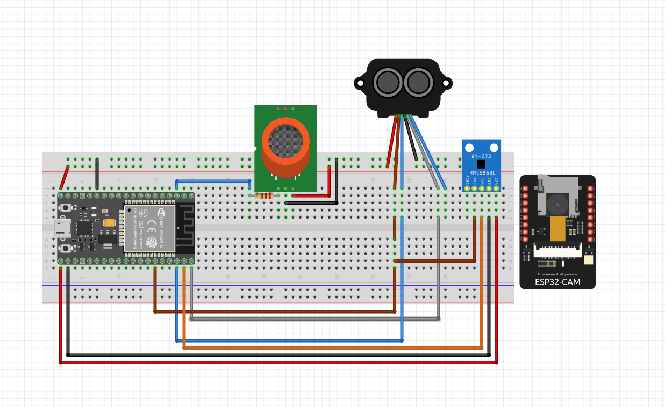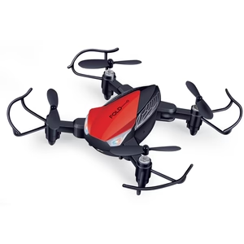

##### Figure 4.0 Block diagrams for system

## High level architecture

System Architecture Block Diagram Drawn by luicidchart

This diagram depicts the overall architecture of the framework, showcasing the interaction between the hardware and software components.

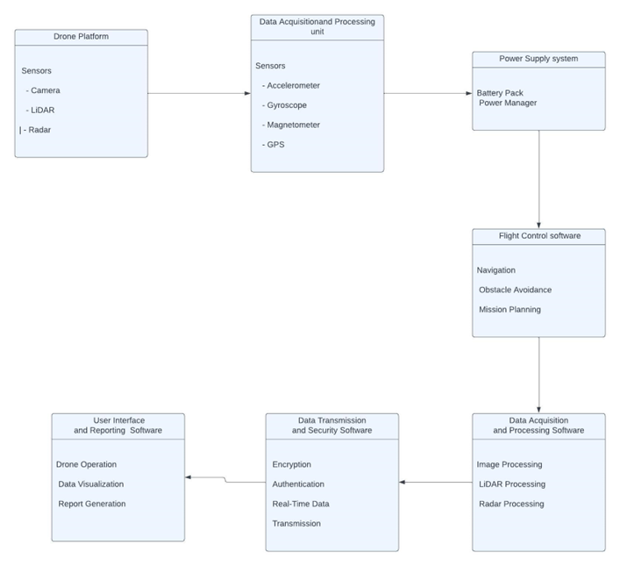

##### Figure 4. System Architecture Block Diagram

**Description of the role and interfaces of key components of the high-level architecture of the proposed drone-based assessment and information transfer framework**:

Data Acquisition and Processing Subsystem:

Role:

* Collects data from infrastructure assets using drone-mounted sensors.
* Processes the collected data to extract meaningful information.
* Stores the processed data for further analysis and reporting.

Interfaces:

* Sensor Interface: Receives data streams from drone-mounted sensors, such as cameras, LiDAR, and Magnetometer.
* Data Processing Interface: Receives sensor data and applies processing algorithms to extract relevant information.
* Data Storage Interface: Stores processed data in a secure and accessible format.

Information Transfer Subsystem:

Role:

* Securely transmits the collected and processed data from the drone to a central server or cloud storage system.
* Employs encryption algorithms and authentication mechanisms to protect sensitive data during transmission.

Interfaces:

* Data Acquisition Interface: Receives processed data from the Data Acquisition and Processing Subsystem.
* Communication Interface: Establishes a secure communication link with the central server or cloud storage system.
* Data Transmission Interface: Transmits encrypted and authenticated data to the central server or cloud storage system.

User Interface and Reporting Subsystem:

Role:

* Enables users to monitor drone flight, visualize collected data, and generate comprehensive assessment reports.

Interfaces:

* User Interface: Interacts with users to receive commands and provide feedback.
* Data Visualization Interface: Receives processed data from the Data Acquisition and Processing Subsystem and visualizes it in an understandable format.
* Reporting Interface: Generates comprehensive assessment reports based on processed data and user input.

Key Interactions between Components:

* Data Acquisition and Processing Subsystem to Information Transfer Subsystem: The Data Acquisition and Processing Subsystem provides processed data to the Information Transfer Subsystem for secure transmission.
* Information Transfer Subsystem to User Interface and Reporting Subsystem: The Information Transfer Subsystem delivers the transmitted data to the User Interface and Reporting Subsystem for visualization and report generation.
* User Interface and Reporting Subsystem to Data Acquisition and Processing Subsystem: The User Interface and Reporting Subsystem may request specific data or processing tasks from the Data Acquisition and Processing Subsystem.

**Drone Flight Control Flowchart:**

This flowchart illustrates the sequence of operations for drone flight control, including pre-flight checks, mission execution, and post-flight procedures.[[30]](https://link.springer.com/article/10.1007/s00163-017-0262-7)

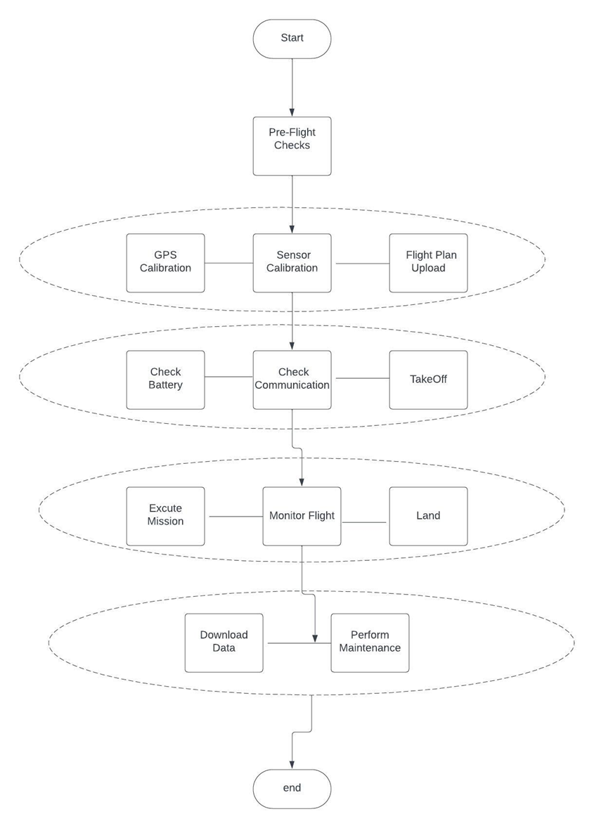

##### Figure 5. Drone Flight Control Flowchart Diagram

**User Interface and Reporting Flowchart:**

This flowchart outlines the user interaction sequence for drone operation, data visualization, and report generation.

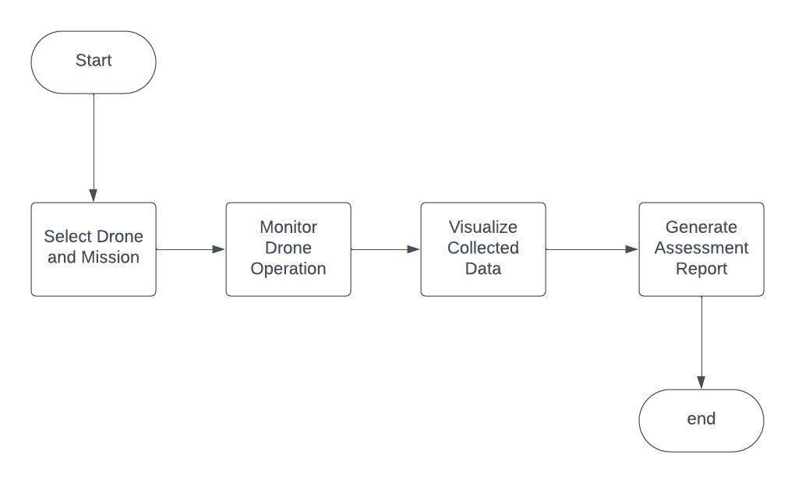

##### Figure 6. User Interface and Reporting Flowchart Diagram

**Overall Software Logic:**

The software logic orchestrates the interactions between the various components of the framework, ensuring seamless data collection, processing, transmission, and user interaction. It encapsulates the algorithms, protocols, and functionalities necessary to achieve the framework’s objectives of comprehensive infrastructure assessment and information transfer.[[30]](https://link.springer.com/article/10.1007/s00163-017-0262-7)

## Design alternatives

# Table 7. Design alternatives

|  |  |  |
| --- | --- | --- |
| Fundamental Design Principle | Engineering Design Methodologies | Specific Implementation |
| Functionality | Modular Design | The framework is divided into modular subsystems, each with a specific function, such as data acquisition, processing, transmission, and user interaction. This modularity enhances flexibility, maintainability, and reusability. |
| Safety | Design for safety | The framework incorporates safety features to minimize the risk of accidents and injuries, including pre-flight checks, obstacle avoidance algorithms, and fail-safe mechanisms. |
| Reliability | Robust Design | The framework employs robust hardware and software components to ensure reliable operation and minimize downtime. Redundancy is incorporated in critical systems to prevent single points of failure. |
| Manufacturability | Cost-effective design | The framework utilizes commercially available hardware and software components to reduce costs and ensure wide-scale adoption. The design is optimized for ease of assembly and maintenance. |
| Usability | User-centered design | The framework prioritizes user needs and provides a user-friendly interface for drone operation, data visualization, and report generation. User feedback is incorporated into the design process to ensure continuous improvement. |
| Performance | Efficient algorithms | The framework employs efficient algorithms for data processing, transmission, and analysis to maximize performance and minimize latency. |
| Maintainability | Modular design | The modular design simplifies maintenance tasks and enables easy replacement of faulty components. Detailed documentation and diagnostic tools are provided to facilitate troubleshooting. |
| Testability | Design for testability | The framework is designed with testability in mind, allowing for thorough testing of individual components and the overall system to ensure functionality, reliability, and performance. |
| Scalability | Flexible architecture | The framework’s architecture is designed to be scalable, allowing for the integration of additional sensors, expansion of coverage area, and adaptation to future technological advancements. |
| Sustainability | Environmentally friendly design | The framework is designed to minimize environmental impact through the use of energy-efficient components, low-emission drones, and sustainable data storage practices. |

In the design of our drone-based assessment and information transfer framework to guarantee its functionality, safety, dependability, manufacturability, usability, performance, maintainability, testability, scalability, and sustainability. Most of the SDPs in use fit under categories C and D, which suggests that testing and feedback are used to enhance designs iteratively.

The project employs a modular design approach, categorized as a C-level SDP, with distinct subsystems and well-defined interfaces, fostering flexibility, maintainability, and reusability. Another crucial C-level SDP is user-centered design, prioritizing user needs through testing and feedback to enhance usability. Safety is emphasized as a C-level SDP, with fail-safe procedures and obstacle avoidance algorithms for drone usage. Robust Design, a D-level SDP, ensures framework reliability by utilizing proven hardware and software with redundancy. Cost-effective design, also a D-level SDP, targets widespread usability by minimizing complexity and optimizing manufacturing. Effective algorithms, a D-level SDP, maximize performance in data processing, transmission, and analysis.

**Comparison of two competing designs for a drone-based assessment and information transfer framework, based on design constraints:**

Design Option 1: Quadcopter Drone with Multi-Sensor Payload

This design utilizes a quadcopter drone platform with a payload capacity capable of accommodating multiple sensors, including a high-resolution camera, LiDAR, and radar. The drone is controlled by a powerful microcontroller or microprocessor that can handle the real-time data processing and transmission requirements of the framework. The power supply system consists of a high-capacity battery pack that provides sufficient flight time for comprehensive infrastructure assessments.

Advantages:

* Versatility: The multi-sensor payload enables the collection of diverse data types, providing a comprehensive assessment of infrastructure assets.
* Robustness: The quadcopter platform is a stable and versatile drone design, suitable for a wide range of operating environments.
* High-Performance Processing: A powerful microcontroller or microprocessor ensures real-time data processing and efficient operation.

Disadvantages:

* Increased Complexity: The multiple sensors and processing requirements add complexity to the system, potentially increasing maintenance needs and cost.
* Higher Power Consumption: The multi-sensor payload and processing requirements increase power consumption, necessitating a larger battery pack.
* Weight Considerations: The additional weight of the sensors and battery pack may impact the drone’s flight performance and payload capacity.

Design Option 2: Fixed-Wing Drone with Dedicated Sensors

This design utilizes a fixed-wing drone platform with dedicated sensors tailored to specific infrastructure assessment tasks. For instance, a fixed-wing drone equipped with a high-resolution camera can focus on detailed imagery capture, while a drone equipped with LiDAR can prioritize 3D point cloud generation. The drone is controlled by a microcontroller or microprocessor optimized for the specific sensor payload. The power supply system is tailored to the drone’s flight time and power requirements.

Advantages:

* Specialized Performance: The dedicated sensors allow for optimized performance for specific assessment tasks.
* Reduced Complexity: The simplified sensor payload and processing requirements reduce system complexity and maintenance needs.
* Improved Flight Time: The fixed-wing design offers longer flight times compared to quadcopters, potentially covering larger areas.

Disadvantages:

* Limited Versatility: The dedicated sensor payload restricts the framework’s ability to collect diverse data types.
* Adaptability Challenges: Adapting the framework to new assessment tasks may require additional hardware or software modifications.
* Maneuverability Limitations: Fixed-wing drones generally have limited maneuverability compared to quadcopters, potentially affecting operation in confined spaces.

Design Choice:

Based on the evaluation of design constraints and the effect of design choices, we recommend Design Option 1: Quadcopter Drone with Multi-Sensor Payload. The versatility of the multi-sensor payload allows for comprehensive infrastructure assessments, while the robustness of the quadcopter platform ensures adaptability to various operating environments. The higher power consumption and increased complexity are considered acceptable trade-offs for the enhanced capabilities.

The fixed-wing drone design offers advantages in terms of specialized performance and flight time; however, its limitations in versatility and maneuverability make it less suitable for the overall requirements of the drone-based assessment and information transfer framework.

The choice of Design Option 1 aligns with the project’s goal of providing a comprehensive and versatile infrastructure assessment solution that can adapt to diverse assessment needs and operating environments. [[31]](https://www.sciencedirect.com/science/article/abs/pii/S0141933120303094)

# Table 8. Design alternatives

|  |  |  |
| --- | --- | --- |
| Parameter | Design Option 1: Quadcopter Drone with Multi-Sensor Payload | Design Option 2: Fixed-Wing Drone with Dedicated Sensors |
| Cost | Higher cost due to multiple sensors and processing requirements | Lower cost due to dedicated sensors and simplified design |
| Ease of use | More complex to operate due to multiple sensors and data processing demands | Easier to operate due to dedicated sensors and streamlined functionality |
| Marketability | Broader appeal due to versatility and wider range of applications | Narrower focus may limit market appeal |
| Ease of manufacturing | More complex manufacturing process due to multiple sensors and integration challenges | Simpler manufacturing process due to dedicated sensors and streamlined design |
| Development time | Longer development time due to integration of multiple sensors and processing algorithms | Shorter development time due to focused design and dedicated sensors |

As our ultimate design option, we suggest Design Option 1: Quadcopter Drone with Multi-Sensor Payload based on this comparison. The project’s goals are greatly aided by the multi-sensor payload’s adaptability and the quadcopter platform’s durability. Although Design Option 2 is less expensive and simpler to use, it is less adaptable and maneuverable, which makes it less appropriate for the overall needs of the drone-based evaluation and information transfer framework. [[31]](https://www.sciencedirect.com/science/article/abs/pii/S0141933120303094)

## Hardware/software used

# Table 9. Needed HW

|  |  |  |
| --- | --- | --- |
| HW details | Platform | Justifications |
| ESP32 microcontroller   | - dual-core 32-bit processor  - built-in Wi-Fi and Bluetooth  - RAM and Flash memory  - 2.2 to 3.6V Operating voltage range | ESP32 is versatile microcontroller:  - Handle sensor data.  - Communicate with other components.  - Assist in controlling the drone. |
| **Gas sensor (MQ-2)**   | - Built in Power Indicator LED and Low TTL Indicator LED  - Operating Voltage is +5V  - Can be used to Measure or detect LPG, Alcohol, Propane, Hydrogen, CO and even methane  - Preheat duration 20 seconds  - Can be used as a Digital or analog sensor  - Air quality monitor  - Gas leak alarm  - Safety standard maintenance | - Crucial for detecting and monitoring gas levels around infrastructure like pipeline.  - Important for safety and early detection of potential issue.  - Light and cheap. |
|  | - weight 0.176 ounces.  - Range resolution: 1cm  - Supply voltage: 5V±0.1V  - 1x USB To RS232 TTL Converter Module  - 1x Serial Cable 15cm | - Valuable for creating 3D maps of the infrastructure  - Helps in identifying structural issues, measuring distance and creating a more detailed overview of the inspection area.  - Security and obstacle avoidance  - Drone altitude holding and terrain following  - Distance measuring instrument |
|  | - 4M memory storage.  - Bluetooth, Wi-Fi, USB and ethernet connectivity.  - quad-core Cortex-A72 (ARM v8) 64-bit.  - weight 1.76 ounces. | - It can serve as a powerful on-board computer for the drone.  - Handle real-time data processing, image analysis and possibly even machine learning tasks.  - It provides flexibility in programming and interfacing with various sensors. |
| Magnetometer sensor ( HMC5883L)   | - 3-axis magnetic field  -  Low power consumption  - I2C communication interface  - voltage of 3-5V can be supplied  - Dimensions (pprox..): 16m x 18mm | - It used to find the location by knowing the 3D direction |
| ESP32 camera | - RAM memory: 512 MB  - connectivity technology: Bluetooth, I2C, wireless  - dual-core 32-bit CPU | - It used to have high resolution pictures and videos. |
| Drone | - Lightweight and Foldable - remote control. | - It is essential for the physical inspection of infrastructure.  - it light and good in testing the job of the real drone |

# Table 10. Needed SW

|  |  |  |
| --- | --- | --- |
| SW details | Platform | Justifications |
| Arduino IDE software   | Windows and Mac | - Software application used for programming and uploading code to Arduino boards. Arduino is an open  -Source electronics platform that provides a simple and accessible way to create and prototype electronic projects.  - Used to deal with gas sensor, lidar sensor and others. |
|  | Windows Delivering comprehensive training programs to equip staff with the skills necessary for proficient drone system operation and maintenance. | - Is a high-performance programming language and environment primarily used for numerical computing, data analysis, and visualization.  - MATLAB provides a versatile platform to work with mathematical models, simulate systems, and analyze data.  - Used to deal with lidar sensor to form a 3D picture for the infrastructure. |
|  | Windows and Mac | - company Autodesk (hence the name AutoCAD). It allows you to draw and edit digital 2D and 3D designs more quickly and easily than you could by hand |

## Hardware design

**Microcontroller:** The ESP32 is a versatile microcontroller and system-on-chip (SoC) that has gained significant popularity in the maker and electronics communities. The ESP32 is known for its powerful features, low cost, and built-in Wi-Fi and Bluetooth capabilities, making it suitable for a wide range of applications.

Key features of the ESP32 include:

1. **Dual-Core Processor:** The ESP32 features a dual-core Tensilica Xtensa LX6 processor, which allows for better multitasking and performance optimization in various applications.
2. **Wireless Connectivity:** One of the standout features of the ESP32 is its built-in Wi-Fi and Bluetooth capabilities. This makes it suitable for Internet of Things (IoT) projects, where connectivity is a crucial aspect. The Wi-Fi support allows the ESP32 to connect to local networks and the internet, while Bluetooth enables communication with other devices and peripherals.
3. **Low Power Consumption:** The ESP32 is designed with power efficiency in mind. It includes various low-power modes, making it suitable for battery-powered and energy-efficient applications.
4. 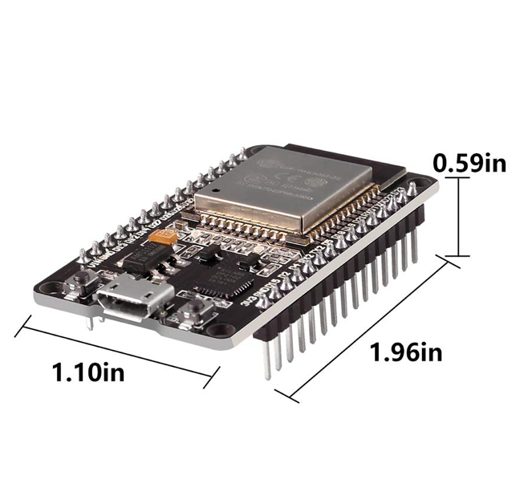**Development Environment:** The ESP32 is well-supported by the Arduino IDE, which makes it accessible to a broad community of developers and hobbyists.

##### Figure 7. ESP32

**Gas sensor:** The MQ-2 is a type of gas sensor commonly used to detect various gases in the air. The MQ sensors are widely used in applications such as gas leakage detection, industrial safety, and air quality monitoring. The MQ-2, in particular, is known for its capability to detect multiple gases.

Here are some key features and information about the MQ-2 gas sensor:

1. **Detectable Gases:** The MQ-2 sensor is designed to detect a range of gases, including LPG (liquefied petroleum gas), propane, methane, carbon monoxide, smoke, and various other combustible gases.
2. **Principle of Operation:** The MQ-2 sensor operates on the principle of metal oxide semiconductors. It contains a sensing element composed of a tin dioxide (SnO2) layer that undergoes changes in electrical conductivity when it comes into contact with the target gases. The resistance of the sensor changes based on the concentration of the detected gas.
3. **Analog Output:** The MQ-2 sensor provides an analog voltage output that can be read by a microcontroller or an analog-to-digital converter. The output voltage is proportional to the concentration of the detected gas.
4. **Heating Element:** The MQ-2 sensor has an integrated heating element that is used to heat the sensing element to a specific temperature, enhancing its sensitivity to the target gases.
5. **Limitations:** While the MQ-2 is versatile, it has some limitations. For instance, it may not provide highly accurate quantitative measurements, and its sensitivity might be affected by environmental factors such as temperature and humidity.
6. 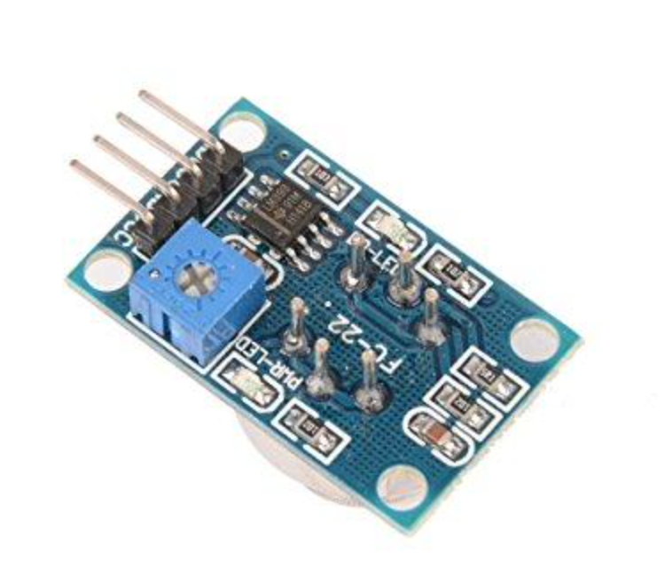**Applications:** The MQ-2 gas sensor finds applications in various scenarios, including gas leak detection in homes, industrial environments, and air quality monitoring. It is commonly used in DIY electronics projects for creating gas sensing systems.

Figure 8. MQ-2

**Lidar sensor:** The TF-Luna is a compact and lightweight Lidar (Light Detection and Ranging) sensor. Lidar sensors use laser light to measure distances and are commonly used for various applications, including robotics, drones, industrial automation, and more. The TF-Luna is known for its small form factor, simplicity, and reliability, making it suitable for a wide range of distance sensing applications.

Here are some key features and information about the TF-Luna Lidar sensor:

1. **Operating Principle:** The TF-Luna sensor utilizes time-of-flight (ToF) technology to measure distances. It emits laser pulses and measures the time it takes for the pulses to reflect off an object and return to the sensor. This information is then used to calculate the distance to the object.
2. **Compact Design:** One of the notable features of the TF-Luna is its compact design. The sensor is small in size and lightweight, making it easy to integrate into various projects and devices.
3. **Measurement Range:** The TF-Luna typically has a measurement range of several meters, and the specific range may vary depending on the model and settings. It is suitable for applications where proximity or distance measurements are required within a defined range.
4. **Communication Interface:** The sensor can communicate with external devices using a variety of interfaces, including UART (Universal Asynchronous Receiver-Transmitter) and I2C (Inter-Integrated Circuit). This makes it compatible with a wide range of microcontrollers and single-board computers.
5. **Ease of Use:** The TF-Luna is designed to be user-friendly and easy to integrate into projects. It often comes with pre-configured settings, simplifying the process of getting distance measurements without requiring extensive programming.
6. **Application Areas:** TF-Luna Lidar sensors are commonly used in applications such as obstacle avoidance for drones and robots, distance measurement for industrial automation, and position sensing for various electronic projects.
7. **Anti-Interference Technology:** The sensor is often equipped with anti-interference technology to minimize the impact of environmental factors such as ambient light and other Lidar devices operating in the vicinity.
8. **Versatility:** The TF-Luna’s small size and versatility make it suitable for both hobbyist and professional projects. It can be easily integrated into devices with size constraints, providing reliable distance measurement capabilities.

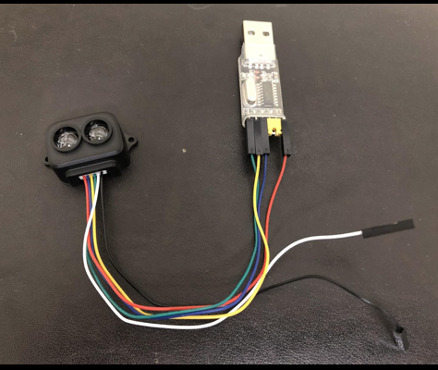

##### figure 9. TF-Luna

**Magnetometer** **sensor (HMC5883L)** : The magnetometer sensor is designed to provide high-accuracy magnetometer measurements, making it suitable for applications that require precise sensing of the magnetic field. It used to find the location by knowing the 3D direction.

Here are some key features and information about the magnetometer chip:

1. **High Accuracy:** it is known for its high accuracy in measuring magnetic fields. It is designed to provide reliable and precise data, making it suitable for applications where accurate magnetometry is essential.
2. **Geomagnetic Sensing:** The primary function of the chip is to sense and measure the magnetic field. This makes it particularly useful in electronic compass modules and navigation systems, where determining orientation and heading accurately is critical.
3. **I2C Interface:** it is making efficient data transfer between the magnetometer and the host system.
4. **High-Resolution Output:** The chip is capable of providing high-resolution magnetic field measurements, allowing for detailed and precise sensing of magnetic variations in the environment.
5. **Arduino Compatibility:** The mention of compatibility with Arduino suggests that there may be libraries or example code available for users who want to interface the chip with Arduino microcontrollers. This can simplify the integration of the magnetometer into Arduino-based projects.

##### figure 10. Magnetometer chip

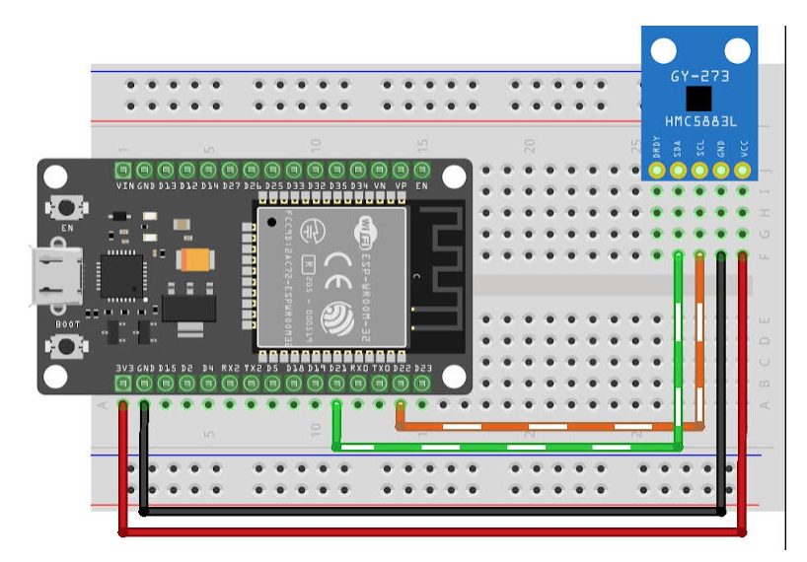

##### figure 11. Magnetometer chip pin

**Raspberry Pi 4:** The Raspberry Pi 4 is offers several key features that make it a versatile and powerful mini-computer for various applications ranging from hobbyist projects to educational purposes. Here are some of the most notable features:

1. **Processor**: It is equipped with a more powerful Broadcom BCM2711, Quad core Cortex-A72 (ARM v8) 64-bit SoC clocked at 1.5GHz, which provides significantly improved processing speeds compared to its predecessors.
2. **Memory Options**: The Raspberry Pi 4 comes in several RAM options, including 2GB, 4GB, and 8GB of LPDDR4 SDRAM. This is a substantial increase from the maximum of 1GB in the Raspberry Pi 3 and allows for more robust applications and multitasking.
3. **Dual Display Support**: It supports dual monitors at resolutions up to 4K via two micro HDMI ports, allowing for an extended desktop environment. This is a major upgrade for users interested in using the Raspberry Pi for desktop computing or digital signage with higher resolution displays.
4. **USB Ports**: The Raspberry Pi 4 features two USB 3.0 ports and two USB 2.0 ports, providing faster data transfer speeds and better device connectivity.
5. **Networking**: It includes Gigabit Ethernet, which is a significant improvement over the 10/100 Ethernet in previous models. Additionally, it supports 2.4 GHz and 5.0 GHz IEEE 802.11ac wireless, along with Bluetooth 5.0, providing versatile networking options.
6. **Power Supply**: It uses a USB-C connector for its power supply, supporting an input of 5V 3A, necessary to support its increased power requirements.
7. **Improved Thermal Management**: The Raspberry Pi 4 generates more heat due to its increased processing power, so it often benefits from a case with a fan or heatsinks to manage temperature effectively.
8. **PIO (Programmable Input/Output)**: Although not exclusively a feature of the hardware itself, the Raspberry Pi Pico, a microcontroller in the Raspberry Pi family, introduced a versatile PIO subsystem. This feature, embraced by the community, enables users to extend the Pi’s interfaces and control over a variety of digital protocols.

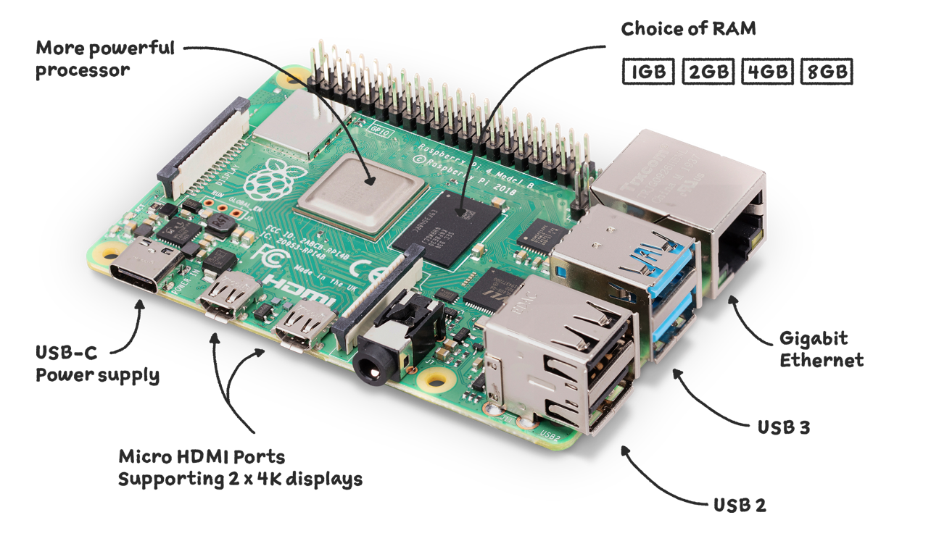

##### Figure12.Raspberry Pi 4

**ESP32 camera:** The ESP32-CAM is a small camera module that can be used in various IoT applications, and its key feature is its integration of Wi-Fi and Bluetooth capabilities along with an image sensor, making it highly suitable for projects involving remote image capture and control. Here are some of the notable features that make the ESP32-CAM a powerful choice for IoT and embedded system applications:

1. **Wi-Fi and Bluetooth**: The module includes the ESP32 chipset, which supports both Wi-Fi and Bluetooth connectivity. This allows for easy remote access and control over the camera, as well as the ability to transmit the captured images and videos over the internet or a Bluetooth network.
2. **Image Sensor**: The ESP32-CAM typically uses an OV2640 camera sensor capable of capturing 2 megapixel images. This sensor can capture and stream video at a resolution of up to 1600x1200 pixels, which is sufficient for many applications such as surveillance, face recognition, and remote monitoring.
3. **Low Cost and Compactness**
4. **SD Card Support**: It includes a slot for a microSD card, providing a means to store photos and videos locally. This is particularly useful in applications where continuous recording is required, or in situations where network connectivity might be intermittent.
5. **Programming Flexibility**: The ESP32-CAM can be programmed using the Arduino IDE, which is familiar to many developers and offers a vast amount of libraries and tools. This makes it relatively easy to develop complex applications that integrate camera functionalities, network features, and other sensor inputs.
6. **Low Power Consumption**: Being part of the ESP32 family, it has low power consumption, making it suitable for battery-powered applications. It also supports various power-saving modes, which is a crucial feature for portable or remote applications.

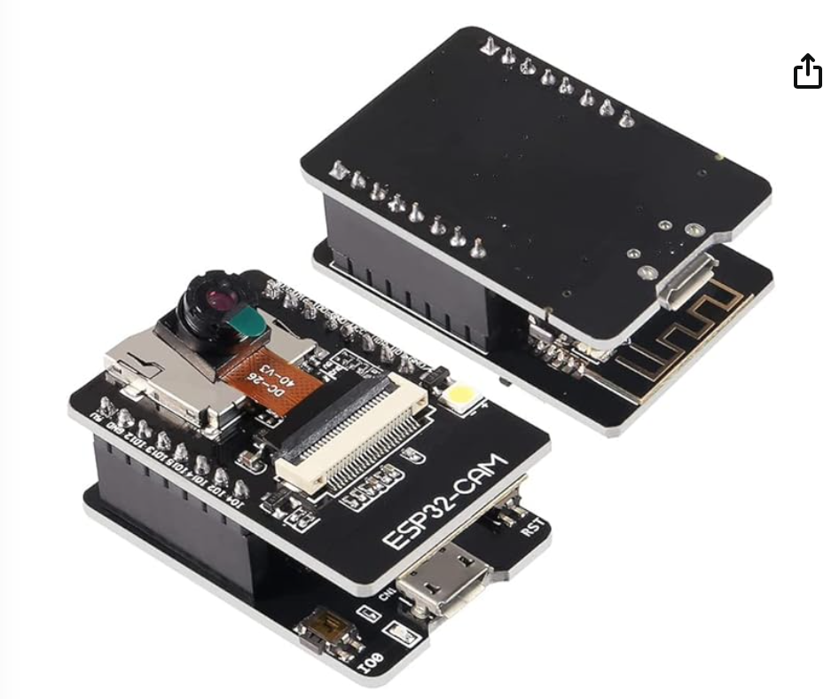

##### Figure13.ESP32COM

**Drone:** The drone which we use has a key features :

1. **Light weight:** its weight is light which help when connect all the sensor on it.
2. **Low price:** it has low price when use it in education manner which be in student budget.
3. **Remote control:** to have the full control when send it to the location of leakage.

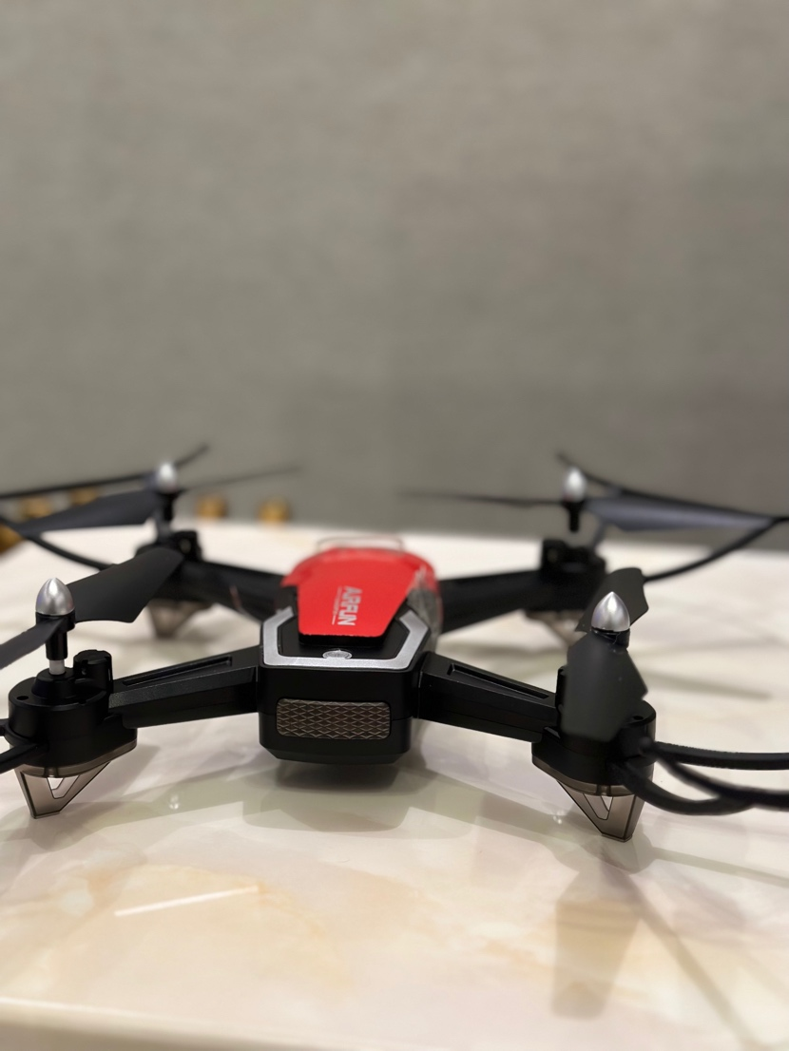

##### Figure14. Drone

## Software design

Before dealing with Arduino IDE and ESP32 we upload the ESP32 library and implement it in the software:

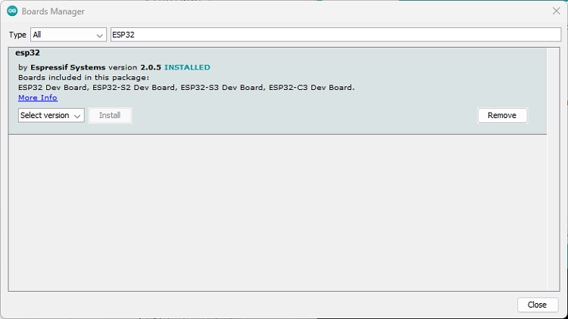

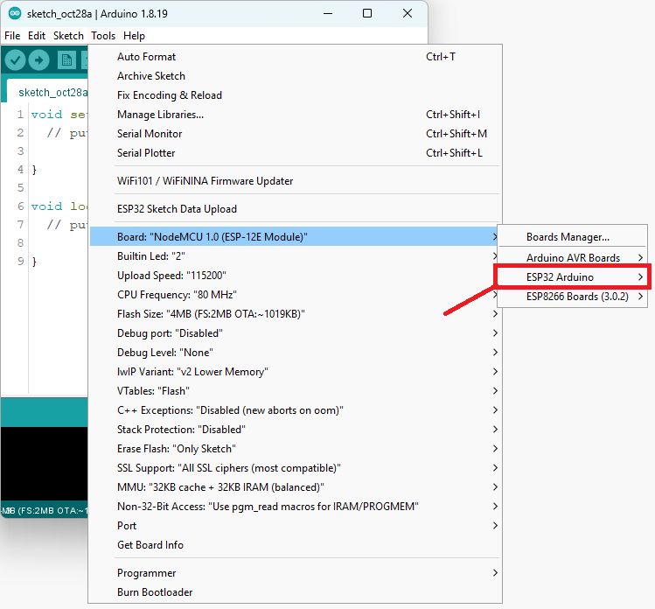

##### figure 15. ESP32 library in Arduino

Now it is ready to use. We connect the sensors and implement them in Arduino software:

1. Coding for Gas sensor:

#define DO_PIN 14  // ESP32’s pin GPIO14 connected to DO pin of the MQ2 sensor

void setup() {

  // initialize serial communication

  Serial.begin(9600);

  // initialize the ESP32’s pin as an input

  pinMode(DO_PIN, INPUT);

  Serial.println(“Warming up the MQ2 sensor”);

  delay(20000);  // wait for the MQ2 to warm up

}

void loop() {

  // Read the digital state of the DO pin connected to the MQ2 sensor

  int gasState = digitalRead(DO_PIN);

  // Check the gas state and print a message based on the result

  if (gasState == HIGH)

    Serial.println(“The gas is NOT present”);

  else

    Serial.println(“The gas is present”);

  delay(20000);  // Print every 20 seconds

}

1. LiDAR sensor:

#include <Wire.h>        // Include the Wire library for I2C communication

#include <TFLI2C.h>      // Include the TFLuna-I2C library v.0.1.1

TFLI2C tflI2C;

int16_t  tfDist;    // Variable to store distance in centimeters

int16_t  tfAddr = TFL_DEF_ADR;  // Set the default I2C address or your custom value

void setup()

{

    Serial.begin(115200);  // Initialize serial port at baud rate 115200

    Wire.begin();           // Initialize Wire library for I2C communication

}

void loop()

{

    tflI2C.getData(tfDist, tfAddr);  // Get data from the TFLuna sensor

    Serial.print(“Distance: “);

    Serial.println(tfDist);  // Print the distance data to the serial monitor

    delay(1000);  // Wait for 1 second before the next iteration

}

1. magnetometer sensor:

// Include necessary libraries for communication and sensor functionality

#include <Wire.h> // Allows communication over I2C

#include <Adafruit_Sensor.h> // Provides unified sensor interface

#include <Adafruit_HMC5883_U.h> // Specific library for HMC5883L magnetometer sensor

// Create an instance of the Adafruit_HMC5883_Unified class to interact with the sensor.

// The parameter (12345) is a sensor ID (can be any number, used for sensor differentiation if multiple).

Adafruit_HMC5883_Unified mag = Adafruit_HMC5883_Unified(12345);

void setup() {

Serial.begin(9600); // Start serial communication at 9600 baud rate

Wire.begin(); // Initialize I2C communication

// Check if the magnetometer was found/initialized successfully.

// If not, print an error message and halt execution.

If (!mag.begin()) {

Serial.println(“Ooops, no HMC5883 detected ... Check your wiring!”);

while (1); // Infinite loop stops further code execution if sensor is not detected

}

}

void loop() {

sensors_event_t event; // Variable to hold the sensor data

mag.getEvent(&event); // Fetch the latest data from the magnetometer

// Calculate the heading (angle) based on the magnetic field readings.

// atan2() calculates the arc tangent of y/x that is in the range of -π to π.

// We convert this angle from radians to degrees by multiplying by (180 / PI).

Float heading = (atan2(event.magnetic.y, event.magnetic.x) * 180) / PI;

// Normalize the heading to be between 0 and 360 degrees

if (heading < 0) {

heading += 360;

}

// Print the calculated heading and raw magnetometer data to the Serial Monitor.

Serial.print(“Heading: “); Serial.println(heading); // Print the heading

Serial.print(“X: “); Serial.print(event.magnetic.x); // Magnetometer X value

Serial.print(“ Y: “); Serial.print(event.magnetic.y); // Magnetometer Y value

Serial.print(“ Z: “); Serial.println(event.magnetic.z); // Magnetometer Z value

delay(500); // Wait half a second (500 milliseconds) before next loop iteration

}

Then we merge the 3 sensors (Lidar, Gas and magnetometer) together in one code:

#include <Wire.h>

#include <TFLI2C.h>

#include <Adafruit_Sensor.h>

#include <Adafruit_HMC5883_U.h>

TFLI2C tflI2C;

Adafruit_HMC5883_Unified mag = Adafruit_HMC5883_Unified(12345);

#define DO_PIN 14 // ESP32’s pin GPIO14 connected to DO pin of the MQ2 sensor

int16_t tfDist; // variable to store distance in centimeter

int16_t tfAddr = TFL_DEF_ADR; // set the default I2C address or your custom value

void setup() {

Serial.begin(115200); // initialize serial port at baud rate 115200

Wire.begin(); // initialize wire library for I2C communication

pinMode(DO_PIN, INPUT);

Serial.println(“warming up the MQ2 sensor”);

delay(20000); // wait for the MQ2 to warm up

Wire.begin(); // Initialize I2C communication

// Check if the magnetometer was found/initialized successfully.

// If not, print an error message and halt execution.

If (!mag.begin()) {

Serial.println(“Ooops, no HMC5883 detected ... Check your wiring!”);

while (1); // Infinite loop stops further code execution if sensor is not detected

}

}

void loop() {

int gasState = digitalRead(DO_PIN);

if (gasState == HIGH) {

Serial.println(“The gas is NOT present”);

} else {

Serial.println(“The gas is present”);

}

tflI2C.getData(tfDist, tfAddr); // get data from the Tfluna sensor

Serial.print(“Distance: “);

Serial.println(tfDist); // print the distance data to the serial monitor

sensors_event_t event; // variable to hold the sensor data

mag.getEvent(&event); // fetch the latest data from the magnetometer

// Calculate the heading (angle) based on the magnetic field readings.

// atan2() calculates the arc tangent of y/x that is in the range of -π to π.

// We convert this angle from radians to degrees by multiplying by (180 / PI).

Float heading = (atan2(event.magnetic.y, event.magnetic.x) * 180) / PI;

// Normalize the heading to be between 0 and 360 degrees

if (heading < 0) {

heading += 360;

}

// Print the calculated heading and raw magnetometer data to the Serial Monitor.

Serial.print(“Heading: “);

Serial.println(heading); // Print the heading

Serial.print(“X: “);

Serial.print(event.magnetic.x); // Magnetometer X value

Serial.print(“ Y: “);

Serial.print(event.magnetic.y); // Magnetometer Y value

Serial.print(“ Z: “);

Serial.println(event.magnetic.z); // Magnetometer Z value

delay(500); // wait half a second (500 milliseconds) before the next loop iteration

}

* We install AutoCAD to generate 3D map for the locations of leakage
* Then we implement codes in MATLAB to get 3 points from the sensors and produce 3D picture for the location of the leakage:

1. **3D Scatter Plot with Gas Concentration Color-Coding:**

This code creates a 3D scatter plot where each point represents a sensor reading at a specific location (X, Y, Z coordinates). The color of each point is determined by the corresponding gas concentration level (GasLevels). The scatter3 function is used to plot the points with color-coding based on gas levels, and colormap is used to choose a color scheme (e.g., ‘jet’). A colorbar is added to the plot to indicate the gas concentration levels represented by different colors. This plot provides a visual representation of gas concentration variations across different locations, allowing you to identify areas with higher or lower gas levels easily.

% Sample gas sensor data (replace with your actual data)

X = [-37.36, -37.45, -37.64, -37.45, -37.64, -37.91];

Y = [23.36, 23.55, 23.55, 23.36, 23.55, 23.64];

Z = [51.33, 51.22, 51.12, 51.33, 51.02, 51.12];

GasLevels = [0.2, 0.5, 0.7, 0.4, 0.9, 0.3]; % Sample gas concentration levels (normalized between 0 and 1)

% Create a 3D scatter plot with color-coded points based on gas levels

scatter3(X, Y, Z, 100, GasLevels, ‘filled’);

colormap(jet); % Choose a colormap (e.g., jet for heatmap-like colors)

colorbar;

xlabel(‘X’);

ylabel(‘Y’);

zlabel(‘Z’);

title(‘3D Scatter Plot with Gas Concentration Color-Coding’);

* + **Mesh plot:**

This code creates a mesh plot based on the sensor data points (X, Y, Z coordinates). It uses griddata to interpolate the Z values and create a smooth surface plot. The mesh function is used to plot the interpolated data on a 3D grid. The Scatter points for the original data are also added to the plot for reference. The resulting plot provides a visual representation of the data’s surface and can help identify trends or patterns.

% Sample data

X = [-37.36, -37.45, -37.64, -37.45, -37.64, -37.91];

Y = [23.36, 23.55, 23.55, 23.36, 23.55, 23.64];

Z = [51.33, 51.22, 51.12, 51.33, 51.02, 51.12];

% Create a meshgrid for X and Y

[Xgrid, Ygrid] = meshgrid(linspace(min(X), max(X), 100), linspace(min(Y), max(Y), 100));

% Interpolate Z values using griddata

Zgrid = griddata(X, Y, Z, Xgrid, Ygrid);

% Create the mesh plot

figure;

mesh(Xgrid, Ygrid, Zgrid);

xlabel(‘X’);

ylabel(‘Y’);

zlabel(‘Z’);

title(‘Mesh Plot of Sensor Data’);

% Add scatter points for the original data

hold on;

scatter3(X, Y, Z, 100, ‘r’, ‘filled’);

hold off;

% Show grid and adjust view

grid on;

view(3);

* Then we take photos and videos from Raspberry pi 4 which connected to the camera using this 2 commands:

**For video:** Raspivid -o video.h264 -t 10000

**For photo:** raspistill -o test.image

* After that we get the images from the Raspberry pi 4 and create a code in MATLAB to detect the leakage:
* **K-Means Clustering:**

Use it when oil leaks form recognizable groups or patterns in the image. It’s like grouping together areas that look similar to each other.

Code:

% K-Means Clustering algorithm

% Load the image

image = imread(‘Picture 4 .jpeg’); % Replace ‘image.jpg’ with the path to your image

% Convert the image to double precision for K-Means clustering

imageDouble = im2double(image);

% Reshape the image into a 2D matrix (rows: pixels, columns: RGB channels)

[nRows, nCols, ~] = size(imageDouble);

pixelValues = reshape(imageDouble, nRows * nCols, []);

% Define the number of clusters (regions)

numClusters = 3; % Adjust as needed

% Perform K-Means clustering

[clusterIndices, clusterCenters] = kmeans(pixelValues, numClusters);

% Reshape the cluster indices back into the original image size

clusterIndicesImage = reshape(clusterIndices, nRows, nCols);

% Visualize the clustered image

imshow(label2rgb(clusterIndicesImage));

* **Region-Based Segmentation:**

Use it when oil leaks have unique characteristics that stand out from the rest of the image, like different colors or textures. It’s like separating a specific area that looks different from the rest.

Code:

% Region-Based Segmentation algorithm

% Load the uploaded image

imagePath = ‘Picture 4 .jpeg’;

image = imread(imagePath);

% Convert the image to double precision for K-Means clustering

imageDouble = im2double(image);

% Reshape the image into a 2D matrix (rows: pixels, columns: RGB channels)

[nRows, nCols, ~] = size(imageDouble);

pixelValues = reshape(imageDouble, nRows * nCols, []);

% Define the number of clusters (regions)

numClusters = 2; % Adjust as needed

% Perform K-Means clustering

[clusterIndices, clusterCenters] = kmeans(pixelValues, numClusters);

% Reshape the cluster indices back into the original image size

clusterIndicesImage = reshape(clusterIndices, nRows, nCols);

% Extract the cluster containing the oil leak (assuming it’s the cluster with the largest mean intensity)

clusterMeans = zeros(numClusters, 1);

for I = 1:numClusters

clusterMeans(i) = mean(pixelValues(clusterIndices == i));

end

[~, leakCluster] = max(clusterMeans);

% Create a binary mask for the detected oil leak region

leakMask = clusterIndicesImage == leakCluster;

% Overlay the detected oil leak region on the original image

leakRegion = bsxfun(@times, image, cast(leakMask, class(image)));

imshow(leakRegion);

* + **Thermal Imaging:**

Use it when oil leaks cause noticeable changes in temperature. It’s like using a special camera that can see heat, and spots with higher temperatures could indicate leaks.

Code:

% Load the thermal image

thermalImage = imread(‘Picture 4 .jpeg’); % Replace ‘thermal_image.jpg’ with the path to your thermal image

% Convert the thermal image to grayscale

grayThermalImage = rgb2gray(thermalImage);

% Define a temperature threshold for detecting oil leaks

temperatureThreshold = 100; % Adjust as needed based on your specific application

% Thresholding: Segment regions with temperature above the threshold

oilLeakRegions = grayThermalImage > temperatureThreshold;

% Optional: Apply morphological operations for noise reduction and region refinement

% oilLeakRegions = imopen(oilLeakRegions, strel(‘disk’, 3)); % Example of morphological opening

% Visualize the detected oil leak regions on the original thermal image

imshow(thermalImage);

hold on;

contour(oilLeakRegions, ‘r’, ‘LineWidth’, 2);

hold off;

* Then we generate a link that can we use it to transfer a file from one machine to another using WebRTC File Transfer — they must be in same network -:
  + First, we install Node.js and npm using these commands:

Sudo apt update

Sudo apt install nodejs npm

* + To verify the installation, check the versions of node.js and npm:

node –version

npm –version

* + Set up the project

mkdir my_project

cd my_project

npm init -y (initialize he instance)

* + Install Express and Socket.IO

npm install express socket.io

* + We create the html web page by using the bellow code
  + Open node server.js
  + Then start sending files

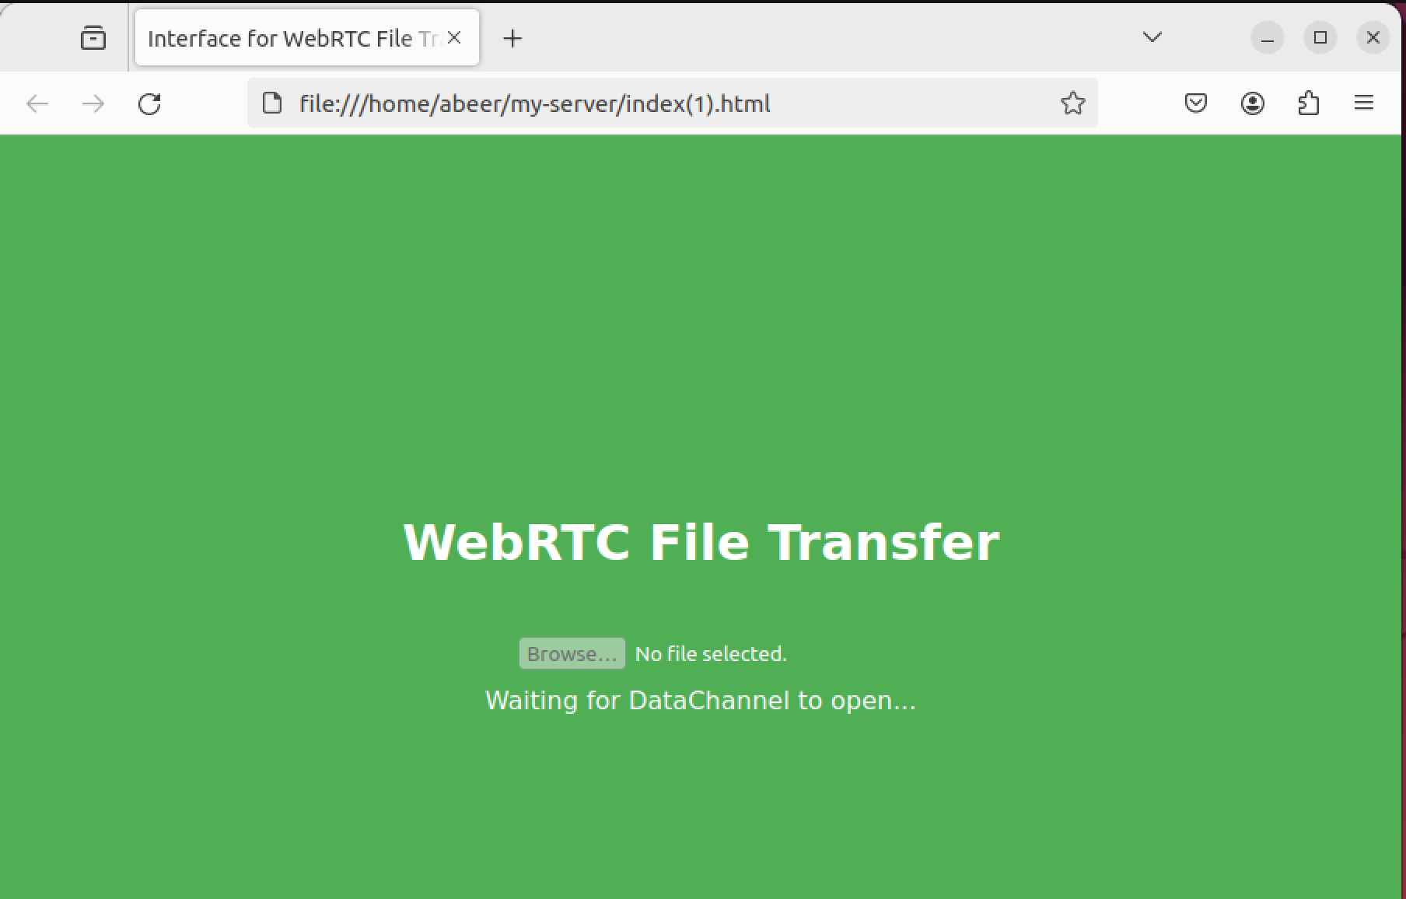

Figure 16. webRTC file transfer

Html Code:

<!DOCTYPE html>

<head>

<title>Interface for WebRTC File Transfer</title>

<style>

body, html {

height: 100%; /* Cover full height of the page */

margin: 0; /* Overwrite default margin */

display: flex; /* Applies Flexbox layout to position center content */

justify-content: center; /* To place the children elements in center horizontally in the Flex container */

align-items: center; /* For vertically centering the children elements in the Flex container */

flex-direction: column;

background-color: #4CAF50; /* Background color of the page */

color: white; /* Font color */

text-align: center; /* Centering text horizontally */

}

.container {

display: flex; /* Applying Flexbox layout to the container */

flex-direction: column; /* Vertically staking children*/

align-items: center; /*Horizontoally Centering children */

justify-content: center; /*Vertically Centering children */

}

.title {

margin-bottom: 20px; /* Spacing after the title*/

}

#fileInput {

margin-bottom: 10px; /* Spacing after the file input element */

}

#status, #fileReceived {

margin-bottom: 15px; /* Spacing below the statusand then some space below the file received elements */

}

button {

padding: 10px 20px; /* For padding inside the button */

background-color: #FF5722; /* Seting the button’s background colorto red */

color: white;

border: none;

cursor: pointer; /* Changing the cursor to a pointer when moving over the button */

transition: background-color 0.3s; /* Changing the background color on cursor over*/

}

button:hover {

background-color: #F44336; /* I the button’s background color when hoveredover by cursor */

}

</style>

</head>

<body>

<div class=”title”>

<h1>WebRTC File Transfer</h1> <!—Setting up main title of the web page 🡪

</div>

<div class=”container”> <!—Wrapping the the interactive elements in a flex container for clear UI🡪

<input type=”file” id=”fileInput” disabled> <!—A file input element, will be disabled by default 🡪

<div id=”status”>Waiting for DataChannel to open...</div> <!—Displays the status of the data channel, will change when connection is established 🡪

<div id=”fileReceived”></div> <!—Received file placeholder 🡪

<button id=”sendFile” style=”display: none;”>Send File</button> <!—Send file button, will be hidden initially 🡪

</div>

<script src=”http://10.180.0.75:3000/socket.io/socket.io.js”></script> <!—Includes the Socket.IO library, IP of the machine running the http server 🡪

<script>

const socket = io(‘http://10.180.0.75:3000’); // Connects to the signaling server using Socket.io, I have the same IP as server running machine

let dataChannel; // Variable for storing the data channel

const peerConnection = new RTCPeerConnection(); // Declearing a new RTCPeerConnection object for WebRTC

// Runs when a data channel creation event is detected, it will store the object

peerConnection.ondatachannel = event => {

dataChannel = event.channel; // Stores the data channel object for further use

setupDataChannelEvents(); // Calls function to setup event listeners for the data channel

};

// Defines a function to setup data channel event listeners

function setupDataChannelEvents() {

dataChannel.onerror = (error) => {

console.error(“Data Channel Error:”, error); // Logs data channel errors

};

// Handles incoming messages over the data channel

dataChannel.onmessage = (event) => {

console.log(“Data Channel Message:”, event.data); // Logs the received data

document.getElementById(‘status’).textContent = ‘File received!’; // Updates status message

// Converts received data into a Blob and creates a download link

const receivedBlob = new Blob([event.data]);

const downloadLink = document.createElement(‘a’);

downloadLink.href = URL.createObjectURL(receivedBlob);

downloadLink.download = ‘received_file’; // Sets a default file name for download

downloadLink.textContent = ‘Click to download the received file’;

document.getElementById(‘fileReceived’).appendChild(downloadLink); // Appends the download link to the DOM

};

// Updates the user interface element when the data channel is open

dataChannel.onopen = () => {

console.log(“Data Channel Opened”);

document.getElementById(‘fileInput’).disabled = false; // Enables the file input element

document.getElementById(‘status’).textContent = ‘DataChannel opened. You can now send a file.’;

};

// Updates the user interface element when the data channel is closed

dataChannel.onclose = () => {

console.log(“Data Channel Closed”);

document.getElementById(‘fileInput’).disabled = true; // Disables the file input element

document.getElementById(‘status’).textContent = ‘DataChannel closed.’;

};

}

// Handles ICE candidate events

peerConnection.onicecandidate = event => {

if (event.candidate) {

socket.emit(‘message’, JSON.stringify({‘ice’: event.candidate})); // Sending the new ICE candidates to the signaling server

}

};

// Handles messages from the signaling server to establish a connection

socket.on(‘message’, message => {

const data = JSON.parse(message);

if (data.ice) {

peerConnection.addIceCandidate(new RTCIceCandidate(data.ice)); // Adds new ICE candidates to the same server for flawless communication

} else if (data.sdp) {

// Sets remote description and creates answer or sets local description accordingly

peerConnection.setRemoteDescription(new RTCSessionDescription(data.sdp)).then(() => {

if (data.sdp.type === ‘offer’) {

peerConnection.createAnswer().then(answer => {

peerConnection.setLocalDescription(answer);

socket.emit(‘message’, JSON.stringify({‘sdp’: answer})); // Sends the answer to the signaling server

});

}

});

}

});

// Creates the data channel and initiates the connection process

dataChannel = peerConnection.createDataChannel(“fileTransfer”);

setupDataChannelEvents(); // Sets up event listeners for the data channel

peerConnection.createOffer().then(offer => {

peerConnection.setLocalDescription(offer);

socket.emit(‘message’, JSON.stringify({‘sdp’: offer})); // Sends the offer to the signaling server

});

// Handles changes to the file input element

document.getElementById(‘fileInput’).addEventListener(‘change’, event => {

const file = event.target.files[0]; // Gets the selected file

if (file) {

const reader = new FileReader();

reader.onload = () => {

// Sends the file over the data channel if it’s open

if (dataChannel && dataChannel.readyState === ‘open’) {

dataChannel.send(reader.result);

} else {

console.error(“Data Channel is not open”);

}

};

reader.readAsArrayBuffer(file); // Reads the file as an ArrayBuffer

}

});

</script>

</body>

</html>

**Coding for esp32 camara:**

1. **Live:**

#include “esp_camera.h”

#include <WiFi.h>

//

// WARNING!!! PSRAM IC required for UXGA resolution and high JPEG quality

// Ensure ESP32 Wrover Module or other board with PSRAM is selected

// Partial images will be transmitted if image exceeds buffer size

//

// You must select partition scheme from the board menu that has at least 3MB APP space.

// Face Recognition is DISABLED for ESP32 and ESP32-S2, because it takes up from 15

// seconds to process single frame. Face Detection is ENABLED if PSRAM is enabled as well

// ===================

// Select camera model

// ===================

//#define CAMERA_MODEL_WROVER_KIT // Has PSRAM

//#define CAMERA_MODEL_ESP_EYE // Has PSRAM

//#define CAMERA_MODEL_ESP32S3_EYE // Has PSRAM

//#define CAMERA_MODEL_M5STACK_PSRAM // Has PSRAM

//#define CAMERA_MODEL_M5STACK_V2_PSRAM // M5Camera version B Has PSRAM

//#define CAMERA_MODEL_M5STACK_WIDE // Has PSRAM

//#define CAMERA_MODEL_M5STACK_ESP32CAM // No PSRAM

//#define CAMERA_MODEL_M5STACK_UNITCAM // No PSRAM

#define CAMERA_MODEL_AI_THINKER // Has PSRAM

//#define CAMERA_MODEL_TTGO_T_JOURNAL // No PSRAM

//#define CAMERA_MODEL_XIAO_ESP32S3 // Has PSRAM

// ** Espressif Internal Boards **

//#define CAMERA_MODEL_ESP32_CAM_BOARD

//#define CAMERA_MODEL_ESP32S2_CAM_BOARD

//#define CAMERA_MODEL_ESP32S3_CAM_LCD

//#define CAMERA_MODEL_DFRobot_FireBeetle2_ESP32S3 // Has PSRAM

//#define CAMERA_MODEL_DFRobot_Romeo_ESP32S3 // Has PSRAM

#include “camera_pins.h”

// ===========================

// Enter your WiFi credentials

// ===========================

const char* ssid = “Hila”;

const char* password = “12345678”;

void startCameraServer();

void setupLedFlash(int pin);

void setup() {

Serial.begin(115200);

Serial.setDebugOutput(true);

Serial.println();

camera_config_t config;

config.ledc_channel = LEDC_CHANNEL_0;

config.ledc_timer = LEDC_TIMER_0;

config.pin_d0 = Y2_GPIO_NUM;

config.pin_d1 = Y3_GPIO_NUM;

config.pin_d2 = Y4_GPIO_NUM;

config.pin_d3 = Y5_GPIO_NUM;

config.pin_d4 = Y6_GPIO_NUM;

config.pin_d5 = Y7_GPIO_NUM;

config.pin_d6 = Y8_GPIO_NUM;

config.pin_d7 = Y9_GPIO_NUM;

config.pin_xclk = XCLK_GPIO_NUM;

config.pin_pclk = PCLK_GPIO_NUM;

config.pin_vsync = VSYNC_GPIO_NUM;

config.pin_href = HREF_GPIO_NUM;

config.pin_sccb_sda = SIOD_GPIO_NUM;

config.pin_sccb_scl = SIOC_GPIO_NUM;

config.pin_pwdn = PWDN_GPIO_NUM;

config.pin_reset = RESET_GPIO_NUM;

config.xclk_freq_hz = 20000000;

config.frame_size = FRAMESIZE_UXGA;

config.pixel_format = PIXFORMAT_JPEG; // for streaming

//config.pixel_format = PIXFORMAT_RGB565; // for face detection/recognition

config.grab_mode = CAMERA_GRAB_WHEN_EMPTY;

config.fb_location = CAMERA_FB_IN_PSRAM;

config.jpeg_quality = 12;

config.fb_count = 1;

// if PSRAM IC present, init with UXGA resolution and higher JPEG quality

// for larger pre-allocated frame buffer.

If(config.pixel_format == PIXFORMAT_JPEG){

if(psramFound()){

config.jpeg_quality = 10;

config.fb_count = 2;

config.grab_mode = CAMERA_GRAB_LATEST;

} else {

// Limit the frame size when PSRAM is not available

config.frame_size = FRAMESIZE_SVGA;

config.fb_location = CAMERA_FB_IN_DRAM;

}

} else {

// Best option for face detection/recognition

config.frame_size = FRAMESIZE_240X240;

#if CONFIG_IDF_TARGET_ESP32S3

config.fb_count = 2;

#endif

}

#if defined(CAMERA_MODEL_ESP_EYE)

pinMode(13, INPUT_PULLUP);

pinMode(14, INPUT_PULLUP);

#endif

// camera init

esp_err_t err = esp_camera_init(&config);

if (err != ESP_OK) {

Serial.printf(“Camera init failed with error 0x%x”, err);

return;

}

sensor_t * s = esp_camera_sensor_get();

// initial sensors are flipped vertically and colors are a bit saturated

if (s->id.PID == OV3660_PID) {

s->set_vflip(s, 1); // flip it back

s->set_brightness(s, 1); // up the brightness just a bit

s->set_saturation(s, -2); // lower the saturation

}

// drop down frame size for higher initial frame rate

if(config.pixel_format == PIXFORMAT_JPEG){

s->set_framesize(s, FRAMESIZE_QVGA);

}

#if defined(CAMERA_MODEL_M5STACK_WIDE) || defined(CAMERA_MODEL_M5STACK_ESP32CAM)

s->set_vflip(s, 1);

s->set_hmirror(s, 1);

#endif

#if defined(CAMERA_MODEL_ESP32S3_EYE)

s->set_vflip(s, 1);

#endif

// Setup LED Flash if LED pin is defined in camera_pins.h

#if defined(LED_GPIO_NUM)

setupLedFlash(LED_GPIO_NUM);

#endif

WiFi.begin(ssid, password);

WiFi.setSleep(false);

while (WiFi.status() != WL_CONNECTED) {

delay(500);

Serial.print(“.”);

}

Serial.println(“”);

Serial.println(“WiFi connected”);

startCameraServer();

Serial.print(“Camera Ready! Use ‘http://”);

Serial.print(WiFi.localIP());

Serial.println(“’ to connect”);

}

void loop() {

// Do nothing. Everything is done in another task by the web server

delay(10000);

}

1. **Picture:**

#include “esp_camera.h”

#include “Arduino.h”

#include “FS.h” // SD Card ESP32

#include “SD_MMC.h” // SD Card ESP32

#include “soc/soc.h” // Disable brownour problems

#include “soc/rtc_cntl_reg.h” // Disable brownour problems

#include “driver/rtc_io.h”

#include <EEPROM.h> // read and write from flash memory

// define the number of bytes you want to access

#define EEPROM_SIZE 1

// Pin definition for CAMERA_MODEL_AI_THINKER

#define PWDN_GPIO_NUM 32

#define RESET_GPIO_NUM -1

#define XCLK_GPIO_NUM 0

#define SIOD_GPIO_NUM 26

#define SIOC_GPIO_NUM 27

#define Y9_GPIO_NUM 35

#define Y8_GPIO_NUM 34

#define Y7_GPIO_NUM 39

#define Y6_GPIO_NUM 36

#define Y5_GPIO_NUM 21

#define Y4_GPIO_NUM 19

#define Y3_GPIO_NUM 18

#define Y2_GPIO_NUM 5

#define VSYNC_GPIO_NUM 25

#define HREF_GPIO_NUM 23

#define PCLK_GPIO_NUM 22

int pictureNumber = 0;

void setup() {

WRITE_PERI_REG(RTC_CNTL_BROWN_OUT_REG, 0); //disable brownout detector

Serial.begin(115200);

//Serial.setDebugOutput(true);

//Serial.println();

camera_config_t config;

config.ledc_channel = LEDC_CHANNEL_0;

config.ledc_timer = LEDC_TIMER_0;

config.pin_d0 = Y2_GPIO_NUM;

config.pin_d1 = Y3_GPIO_NUM;

config.pin_d2 = Y4_GPIO_NUM;

config.pin_d3 = Y5_GPIO_NUM;

config.pin_d4 = Y6_GPIO_NUM;

config.pin_d5 = Y7_GPIO_NUM;

config.pin_d6 = Y8_GPIO_NUM;

config.pin_d7 = Y9_GPIO_NUM;

config.pin_xclk = XCLK_GPIO_NUM;

config.pin_pclk = PCLK_GPIO_NUM;

config.pin_vsync = VSYNC_GPIO_NUM;

config.pin_href = HREF_GPIO_NUM;

config.pin_sscb_sda = SIOD_GPIO_NUM;

config.pin_sscb_scl = SIOC_GPIO_NUM;

config.pin_pwdn = PWDN_GPIO_NUM;

config.pin_reset = RESET_GPIO_NUM;

config.xclk_freq_hz = 20000000;

config.pixel_format = PIXFORMAT_JPEG;

if(psramFound()){

config.frame_size = FRAMESIZE_UXGA; // FRAMESIZE_ + QVGA|CIF|VGA|SVGA|XGA|SXGA|UXGA

config.jpeg_quality = 10;

config.fb_count = 2;

} else {

config.frame_size = FRAMESIZE_SVGA;

config.jpeg_quality = 12;

config.fb_count = 1;

}

// Init Camera

esp_err_t err = esp_camera_init(&config);

if (err != ESP_OK) {

Serial.printf(“Camera init failed with error 0x%x”, err);

return;

}

//Serial.println(“Starting SD Card”);

if(!SD_MMC.begin()){

Serial.println(“SD Card Mount Failed”);

return;

}

uint8_t cardType = SD_MMC.cardType();

if(cardType == CARD_NONE){

Serial.println(“No SD Card attached”);

return;

}

camera_fb_t * fb = NULL;

// Take Picture with Camera

fb = esp_camera_fb_get();

delay(1000);//This is key to avoid an issue with the image being very dark and green. If needed adjust total delay time.

Fb = esp_camera_fb_get();

if(!fb) {

Serial.println(“Camera capture failed”);

return;

}

// initialize EEPROM with predefined size

EEPROM.begin(EEPROM_SIZE);

pictureNumber = EEPROM.read(0) + 1;

// Path where new picture will be saved in SD Card

String path = “/picture” + String(pictureNumber) +”.jpg”;

fs::FS &fs = SD_MMC;

Serial.printf(“Picture file name: %s\n”, path.c_str());

File file = fs.open(path.c_str(), FILE_WRITE);

if(!file){

Serial.println(“Failed to open file in writing mode”);

}

else {

file.write(fb->buf, fb->len); // payload (image), payload length

Serial.printf(“Saved file to path: %s\n”, path.c_str());

EEPROM.write(0, pictureNumber);

EEPROM.commit();

}

file.close();

esp_camera_fb_return(fb);

// Turns off the ESP32-CAM white on-board LED (flash) connected to GPIO 4

pinMode(4, OUTPUT);

digitalWrite(4, LOW);

rtc_gpio_hold_en(GPIO_NUM_4);

esp_deep_sleep_start();

}

void loop() {

}

## New-gained knowledge

In the course of our project, we acquired numerous knowledge and skills pertinent to design, encompassing:

* + Data acquisition involves understanding the importance of using suitable methodologies to gather raw data from sensors, enabling the creation of datasets.
  + Mastering feature selection and engineering is crucial as it can significantly influence the performance of sensors. This entails comprehending the domain and the core problem, as well as conducting exploratory data analysis.
  + Model interpretation and visualization: Gaining the ability to interpret and explain sensors is valuable. Techniques like feature importance analysis, partial dependence plots, and model visualization aids in understanding how the model makes predictions.
  + Deployment and productionization involve acquiring knowledge and skills relevant to implementing sensors in real-world scenarios. This includes understanding how to package models and seamlessly integrate them into existing systems.
  + Knowledge of sensors and technologies used in drones for data collection, such as cameras, LiDAR, and thermal imaging.
  + Skills in capturing high-quality data for inspection purposes.
  + Ability to process and analyze data collected by drones using relevant software.
  + Understanding of GIS **(Geographic Information System)** tools for mapping and spatial analysis and utilizing three-dimensional images provides a realistic representation of what occurs in reality and enhances accuracy.
  + The mesh plot helps us see the overall shape and structure of the area we’re inspecting, like a 3D map showing any bumps or dips in the terrain. It’s like looking at a model of the ground from above.
  + On the other hand, the 3D scatter plot with color-coding shows us where gas levels are higher or lower across that area. It’s like using different colors to see where there might be more or less gas, helping us find potential leaks or areas needing attention.

# Implementation

Our final connection done as following:

1. Implementing the ESP32, learn about the pins and how it works

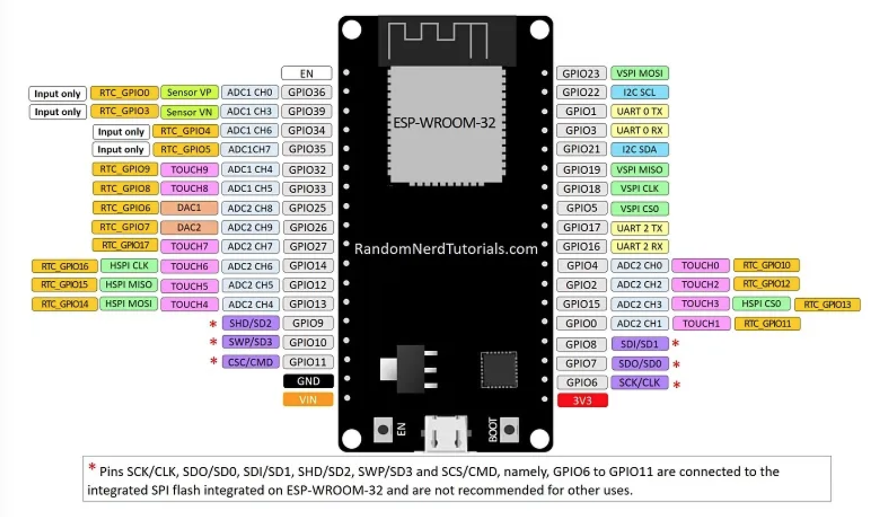

##### Figure 17. ESP32 pins

1. Connecting the gas sensor to the ESP32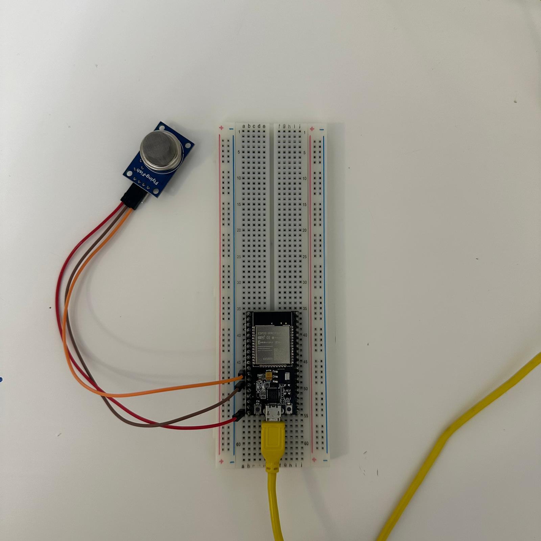

##### Figure 18. gas sensor to the ESP32

* + **Vcc (power):** connected to 5V on ESP32. This provides power to the gas sensor allowing it to operate.
  + **GND (Ground):** connected to GND on ESP32. This establishes a common ground reference between the gas sensor and the ESP32, completing the electrical circuit.
  + **DO (Digital Output):** connected to GPIO14 on ESP32 This is the digital signal output from the gas sensor, this is the digital signal output from the gas sensor, and it is used to convey the digital state of the gas sensor (HIGH or LOW) to the ESP32. The gas sensor typically outputs a HIGH signal when a certain gas concentration exceeds a predefined threshold.

1. Connecting the LiDAR sensor to the ESP32

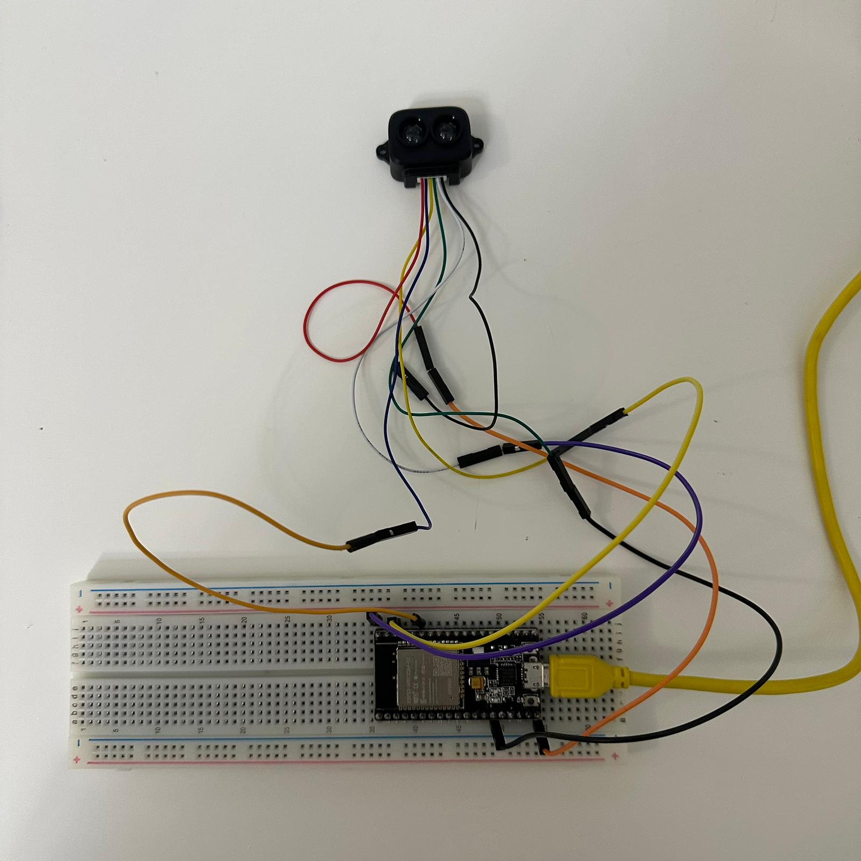

##### Figure 19. LiDAR sensor to the ESP32

* + **5V:** connecting to 5V on ESP32. This connection provide power.
  + **RXD/SDA:** either RXD or SDA connecting to GPIO21 on ESP32. This is the data line for I2C communication.
  + **TXD/SCL:** either TXD or SCL connected to GPIO22 on ESP32. This is the clock line for I2C communication.
  + **GND:** connecting to GND on ESP32 to provides a common ground reference between LiDAR sensor and the ESP32.
  + **I2C ENABLE:** connectingto GND on ESP32. This connection is likely used to enable or disable the I2C communication on the LiDAR sensor. Connecting it to GND usually means enabling I2C.

1. Connect the magnetometer sensor to ESP32 [14]

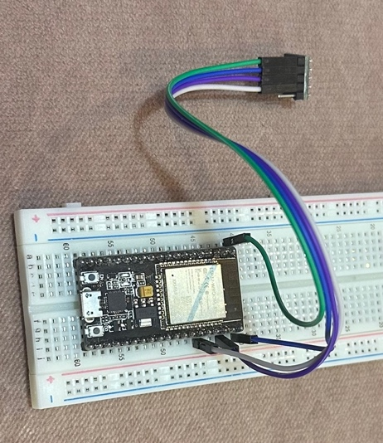

##### Figure 20. magnetometer sensor to the ESP32

* + **Vcc:** connect to 5V on ESP32 to have power.
  + **GND:** connect to GND on ESP32 to have a common ground.
  + **SDA:** connect to GPIO21 on ESP32. This is the data line for I2C communication.
  + **SCL:** connect to GPIO22 on ESP32. This is the clock line for I2C communication.

1. We will implement the Raspberry pi 4 to connect the ESP32 camera:

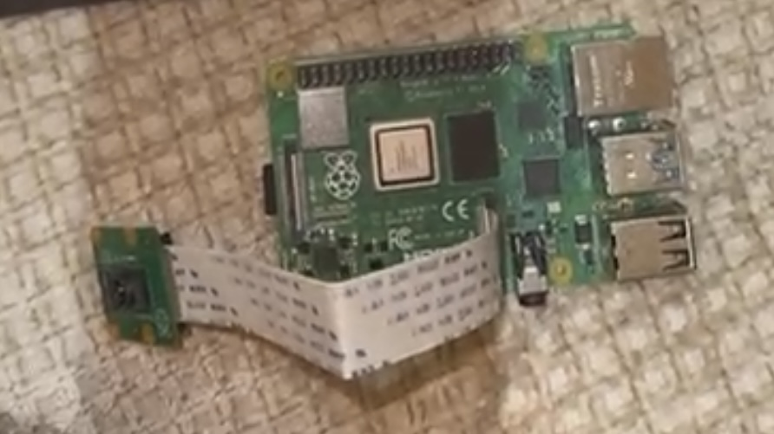

##### Figure 21. Raseberry pi4 with camera

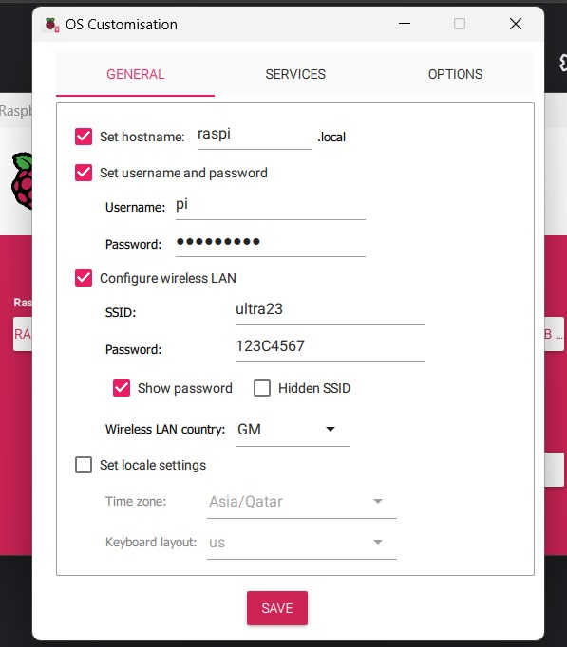

##### Figure 22. Raspberry pi 4 with ESP32 camera config.

The Raspberry pi 4 in connection to a devise that have HDMI and make sure that all connection in the same network (by checking the ip address).

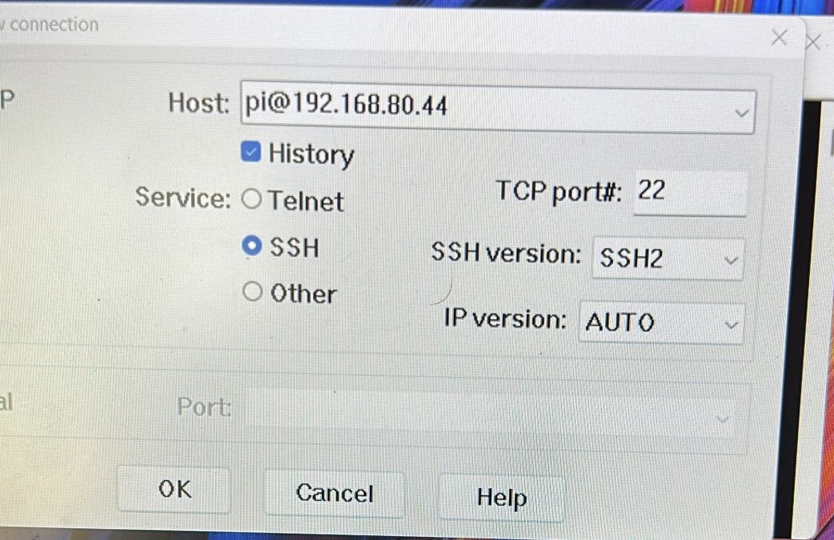

Then after taking the video or photo, it will save them in the SD card which can help to transfer them to another devices.

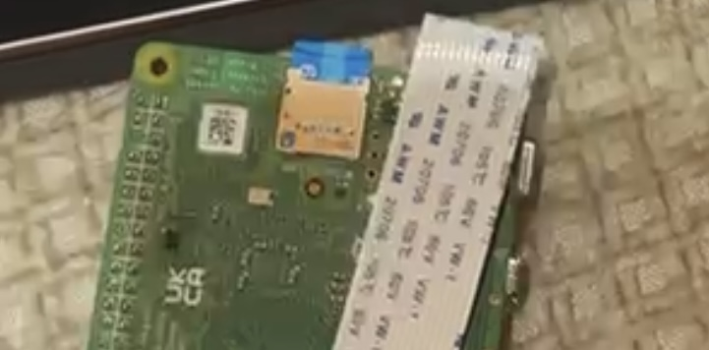



Figure 23. SD card

1. Connect all the sensors to the drone to give a whole system which detect the gas and oil leakage and send a general report to the station.

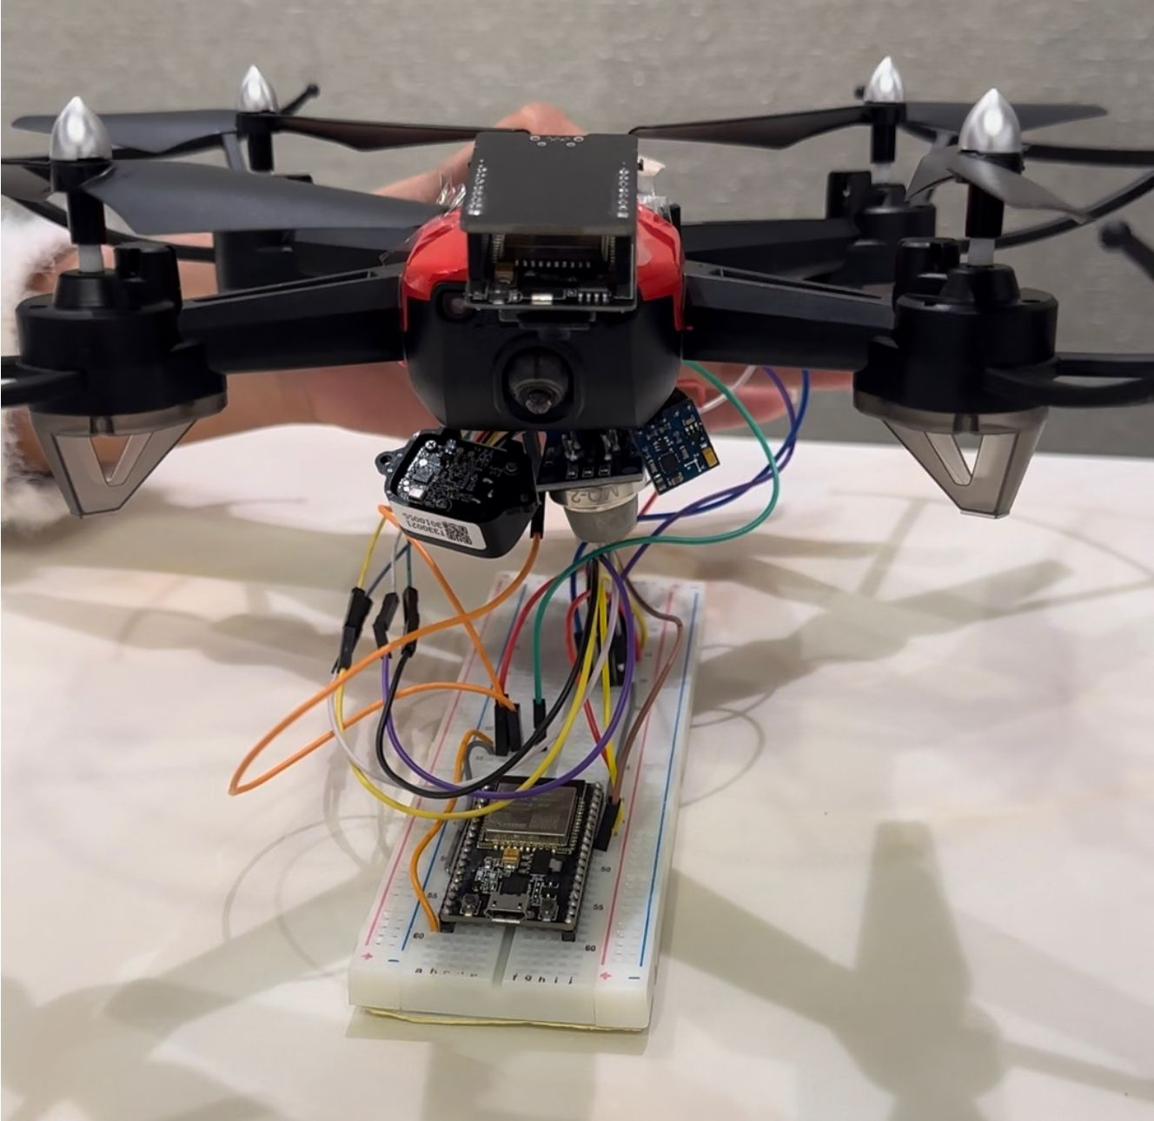

##### Figure 24. Drone and all sensor to the ESP32

# New-gained knowledge

Working in drone-based infrastructure inspection and data transmission involves a combination of technical and soft skills. Here are some key skills that professionals in this field may acquire:

1. **Inspection and Analysis Skills:**
   * **Structural Inspection:** Ability to identify and assess structural issues in infrastructure using drone-collected data.
   * **Defect Recognition:** Skills in recognizing defects, damages, or abnormalities in infrastructure components.
   * **Risk Assessment:** Assessing the risk associated with identified issues and prioritizing them for intervention.
2. **Communication Skills:**
   * **Reporting:** Effectively communicating inspection findings and analysis to stakeholders.
   * **Documentation:** Keeping detailed records of inspections, data, and findings.
3. **Problem-Solving:**
   * **Adaptability:** Ability to adapt to changing conditions and solve problems that may arise during drone operations.
   * **Decision-Making:** Making informed decisions on the best course of action based on inspection findings.
4. **Safety Awareness:**
   * **Risk Management:** Identifying and mitigating potential risks associated with drone operations.
5. **Project Management:**
   * **Time Management:** Efficiently managing time during inspections and data processing.
6. **Collaboration:**
   * **Teamwork:** Collaborating with other professionals, such as engineers and project managers.
7. **Continuous Learning:**
   * **Keeping Up with Technology:** Staying updated on advancements in drone technology and inspection methodologies.
   * **know how to use our previous learning skills like how to use MATLAB to analyze data and obtain new ones.**

# Testing and Evaluation

* + Testing is done in each sensor:
  1. Gas sensor:

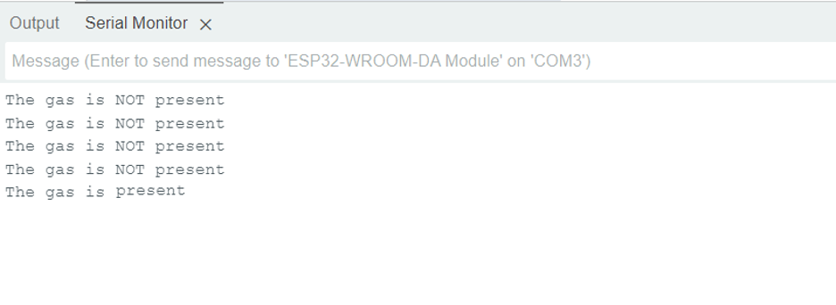

Figure 25. Gas sensor output

When there is no gas the sensor send message “The gas is NOT present”. But when it detects any gas it mediately turn on the alarm and send message “The gas is present.

* 1. LiDAR sensor:

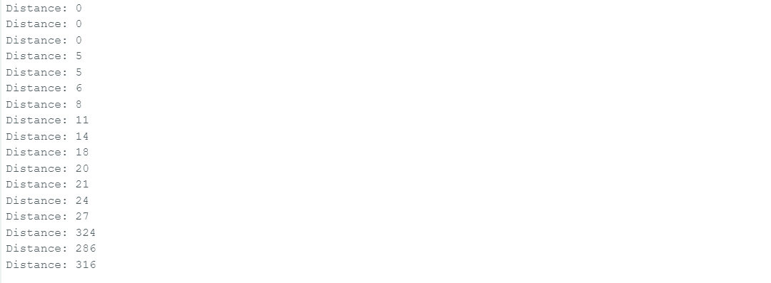

Figure 26. LiDAR sensor output

The distance change due to how far the object is.

* 1. Magnetometer sensor:

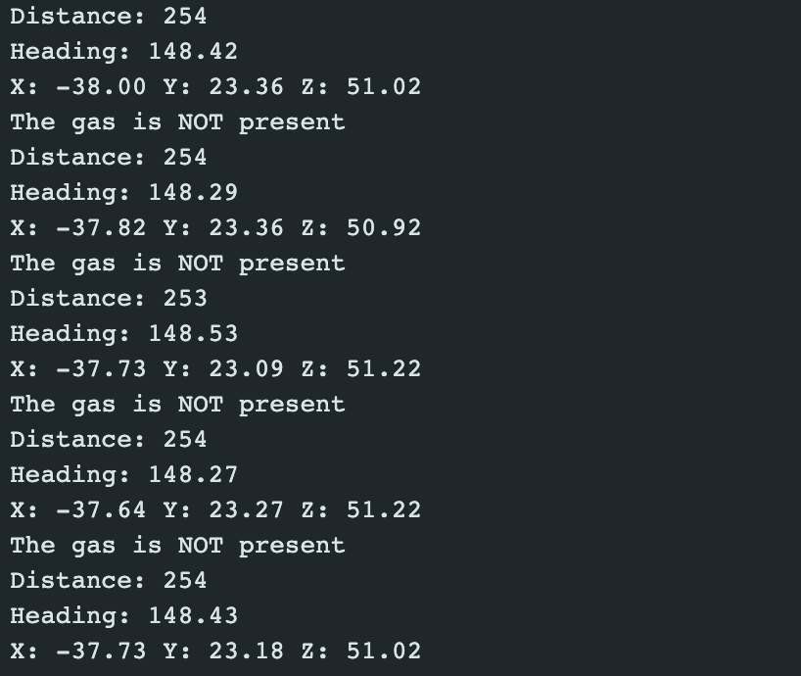

Figure 27. Magnetometer sensor output

This output shows the magnetic heading which refers to the direction it is pointing relative to magnetic north. This direction is determined by a compass, which aligns with the Earth's magnetic field lines. The magnetic heading is typically expressed in degrees from 0° (pointing directly toward magnetic north) to 359°.

Also, it shows the 3-axis x, y, z of any leakage.

D. merging the 3 sensors:



Figure 28. all sensors output

* + Then we draw the pints in AutoCAD to represent the leakage using the 3-axis:

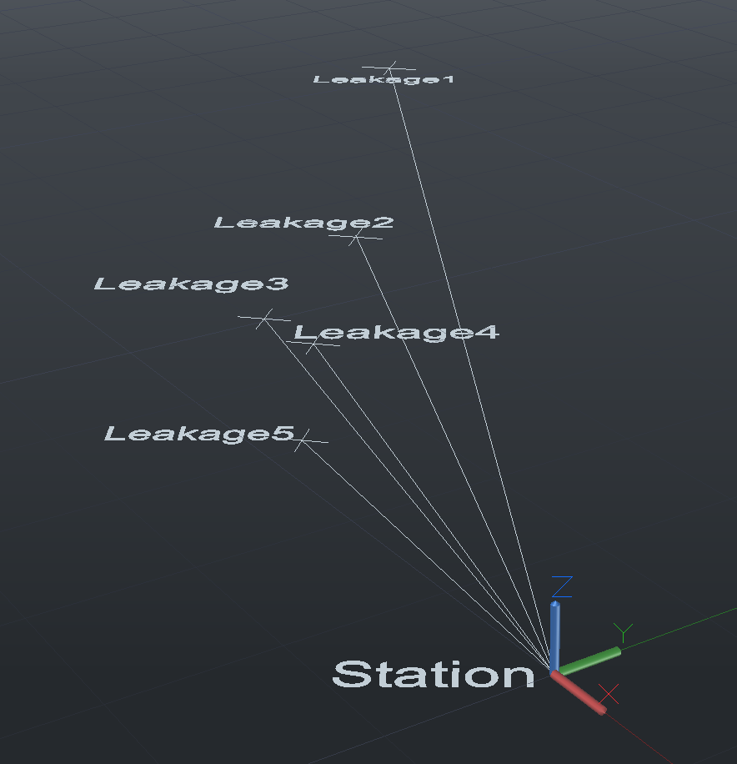

Figure 29. leakage 3D map by AutoCAD

Also, we collect the values to produce 3D figures to give more professional analysis by mesh plot and scatter plot:

**Mesh Plot of Sensor Data:**

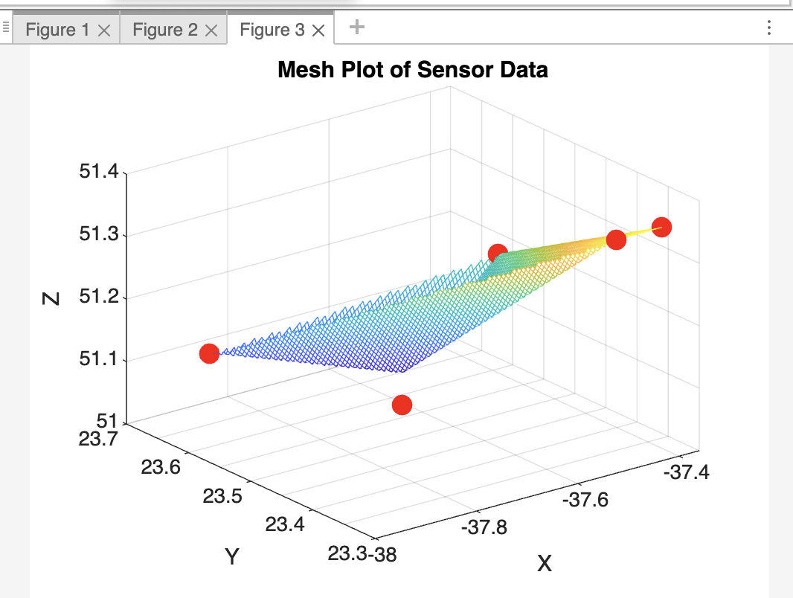

Figure 30. mesh plot of sensor data

**3D Scatter Plot With Gas Concentration Color-Coding:**

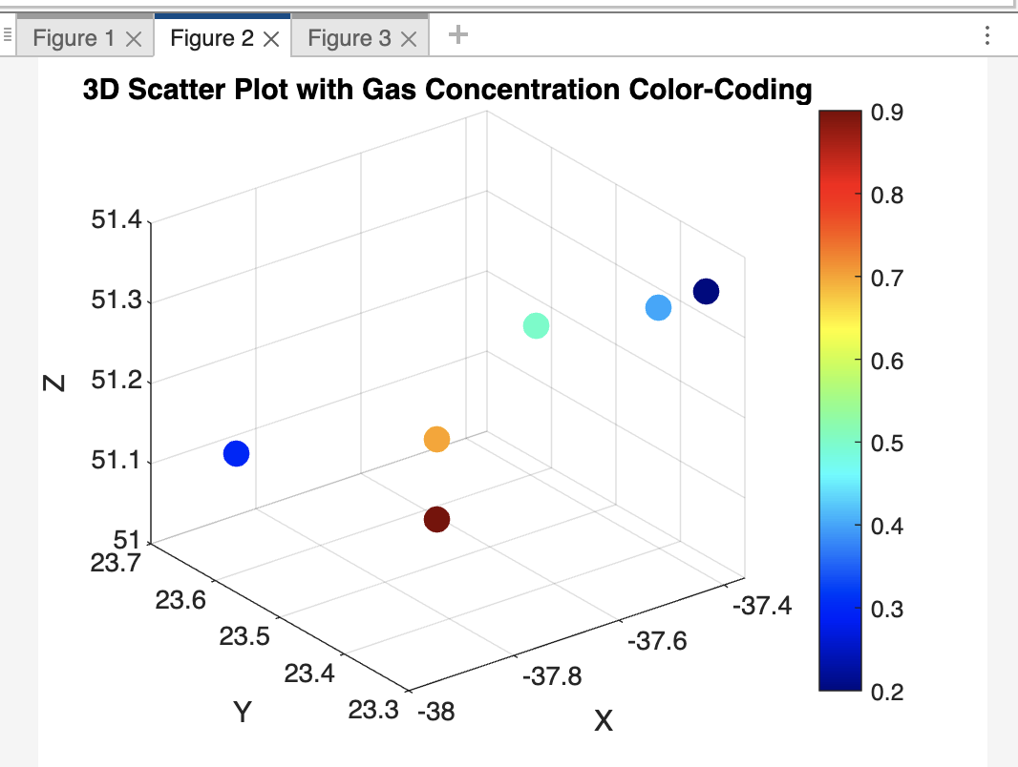

Figure 31. 3D scatter plot

* **Lighter Color (e.g., Yellow, Red):**
  + Higher gas concentration levels or readings.
  + Areas where the gas concentration is above a certain threshold or considered abnormal.
  + Potential leak points or areas of interest that may require further investigation.
* **Darker Color (e.g., Blue, Green):**
  + Lower gas concentration levels or normal readings.
  + Areas where the gas concentration is within expected or safe levels.
  + Typically, darker colors may indicate normal or background levels of gas concentration.
  + Then we take photos using ESP32 camera for the leakage and analyze the photo:
* **Original photo:**



Figure 32. original photo by ESP32 camera

* + 1. **Region-Based Segmentation code output:**
* **No oil leak**

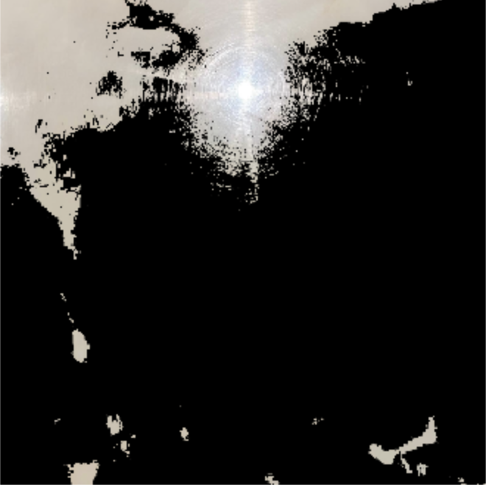

Figure 33. Region-Based Segmentation code output with no oil leak

* **With oil leak**

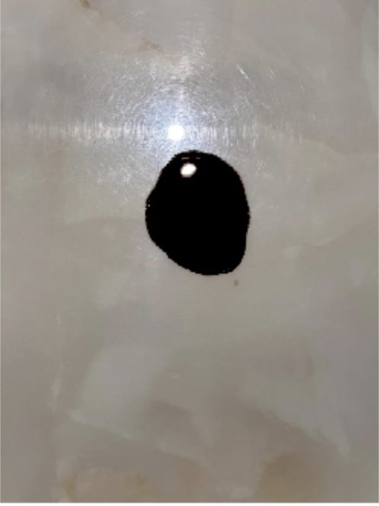

Figure 34. Region-Based Segmentation code output with oil leak

* + 1. **K-Means Clustering code output:**
* **No oil leak :**

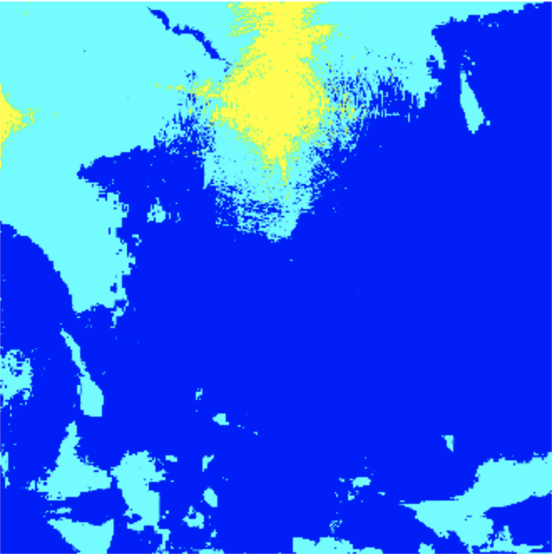

Figure 35. K-Means Clustering code output with no oil leak

* **With oil leak**

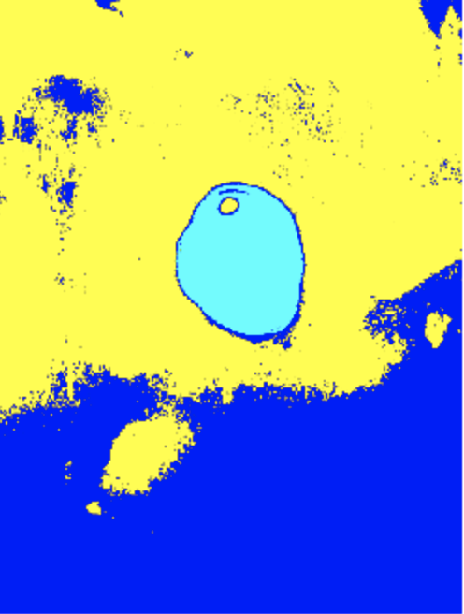

Figure 36. K-Means Clustering code output with oil leak

* + 1. **Thermal Imaging code output :**
* **No oil leak:**



Figure 37. Thermal Imaging code output with no oil leak

* **With oil leak:**

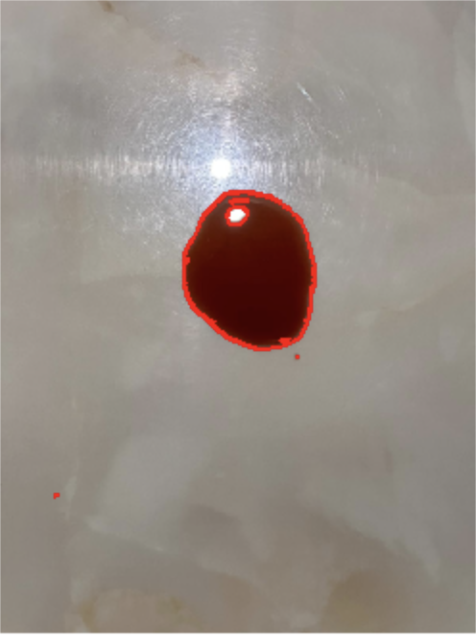

Figure 38. Thermal Imaging code output with oil leak

* + Then when we send a file from one machine to another this is the output, first we open the port

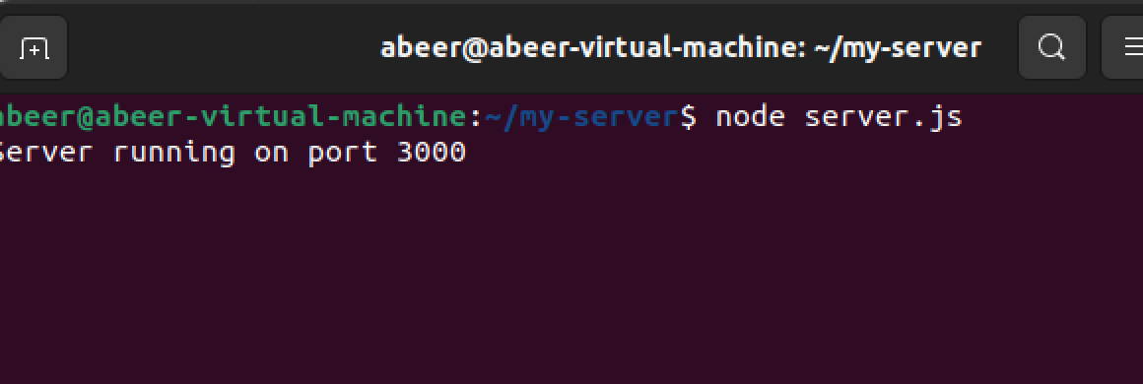

* + Then we can send and receive files

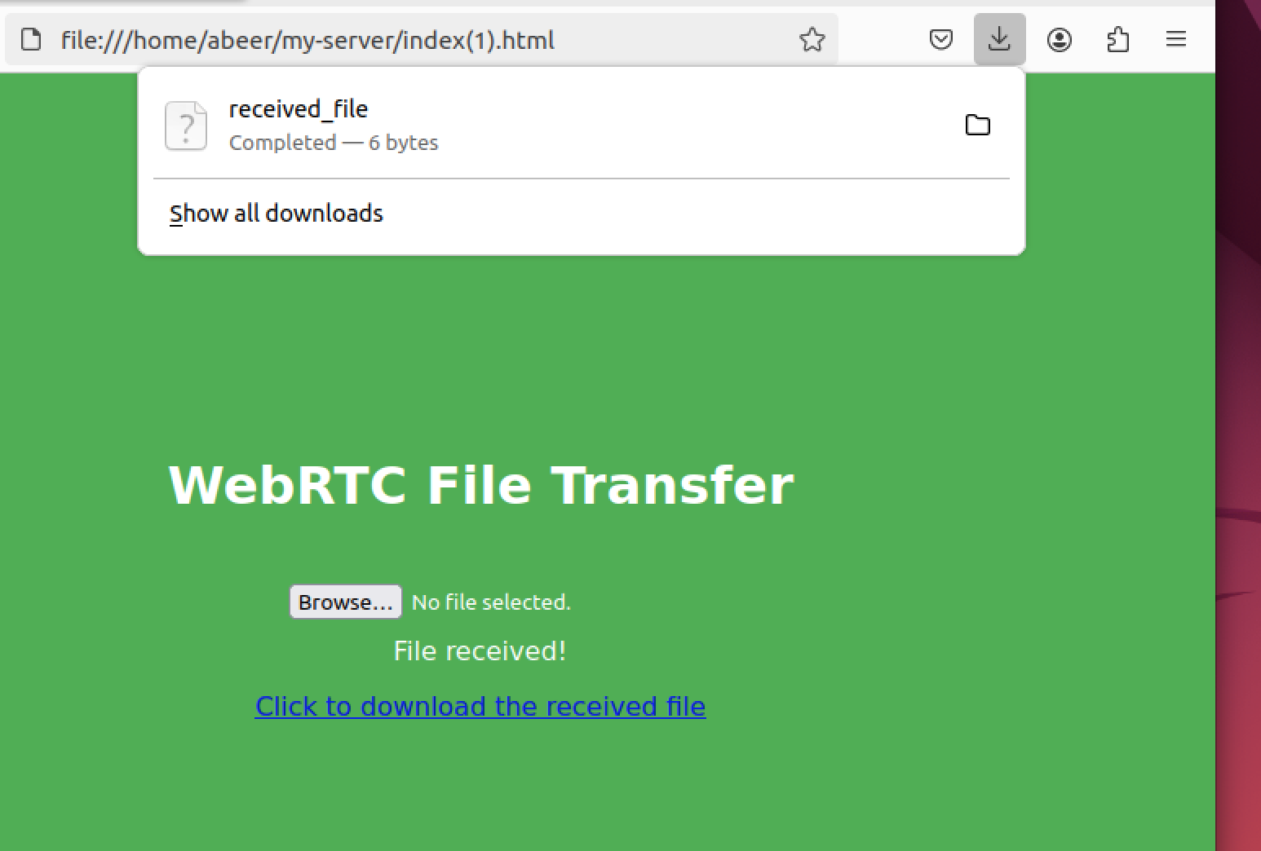

Figure 39. webRTC output

* + Testing ESP32cam:

1. 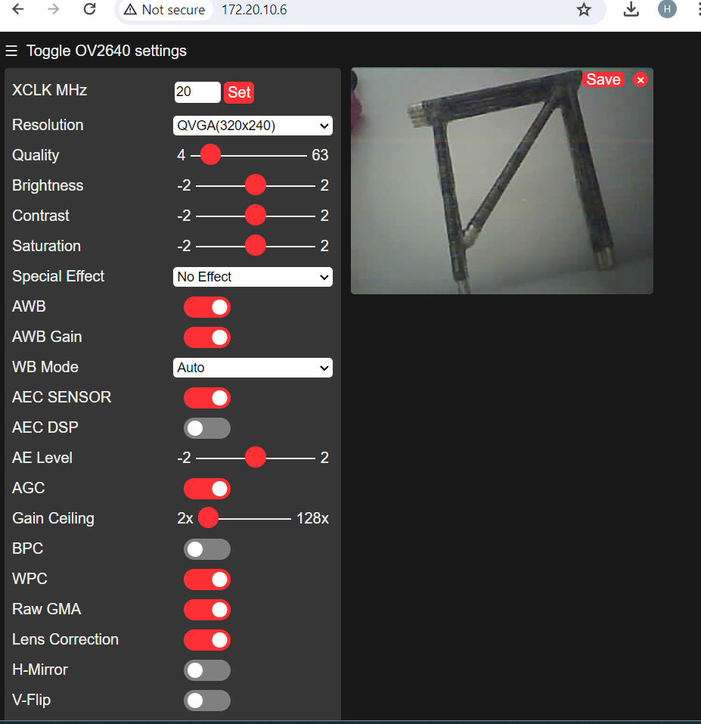Live

Figure 40. WSP32com Live output

1. Picture:

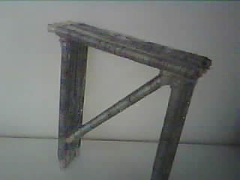

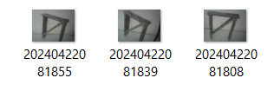

Figure 41. WSP32com photo output

# Analysis of the impact of the engineered solution

Table 8. Analysis of the impact of the engineered solution

|  |  |  |
| --- | --- | --- |
| Context | Specific contribution through the project | Level of impact (High, Medium, low) |
| Global | - Drones can be deployed rapidly in emergency situations, providing real-time data to aid in disaster response and recovery efforts.  - Drones are used to inspect and maintain communication infrastructure such as cell towers and antennas, contributing to improved global connectivity.  - Drones can reach remote or inaccessible areas, aiding in the inspection and maintenance of infrastructure in regions that are otherwise challenging to access. | High |
| Societal | - Drones can access difficult-to-reach or hazardous areas without putting human workers at risk. This is particularly beneficial for inspecting structures like bridges, power lines, and communication towers.  - The growth of drone-based infrastructure inspection has created new job opportunities in fields such as drone piloting, data analysis, and drone technology development. | High |
| Environmental | - Drones generally have a lower environmental impact compared to traditional inspection methods that may involve heavy machinery or extensive ground transportation. | High |
| Economic | - Drones can quickly inspect large areas, reducing the time required for manual inspections. This efficiency leads to cost savings in terms of labor and resources.  - and addressing issues early through regular drone inspections can prevent more extensive and expensive damage to infrastructure, saving long-term costs.  - The industry's expansion contributes to economic growth through the development and sale of drone technology and associated services. | High |
| Health | - Detecting the leaking of gas and oil early can reduce the impact of pollutants emitted from it which reduce the diseases. | Medium |

# Future work

The infrastructure inspection system that utilizes drones offers a viable method for keeping an eye on vital infrastructure. Nonetheless, there exist several domains in which the system can be augmented and refined in the future times.

**Suggested Improvements:**

1. **AI Integration for Anomaly Detection**: Investigate the integration of artificial intelligence (AI) algorithms to detect anomalies and potential issues in infrastructure components, improving predictive maintenance capabilities**.**

**2. Weather Resistance Enhancements:** Engineer drone components and systems to withstand various weather conditions, ensuring consistent performance and data accuracy regardless of environmental factors.

**3. Autonomous Navigation Development:** Invest in research and development to implement autonomous navigation capabilities in the drone system, enabling it to navigate complex environments and optimize inspection routes

**4. Expandable Data Transmission Capacity:** Explore technologies to enhance data transmission capabilities, allowing for the efficient transfer of large volumes of inspection data in real-time.

**5. Enhanced Sensor Integration:** Incorporate more advanced sensors for comprehensive data collection, such as multispectral imaging for detailed surface analysis.

**6. Integration with GIS Platforms:** Integrate the inspection data seamlessly with Geographic Information System (GIS) platforms for enhanced mapping and visualization capabilities.

**7. Collaborative Inspection Systems:** Develop a networked system where multiple drones can collaborate on inspections, improving coverage and efficiency

**8. Continuous Software Updates**: Implement a strategy for regular software updates to ensure the system remains up to date with the latest technological advancements and security patches

**9. Public Awareness Campaigns:** Launch educational campaigns to raise public awareness about the benefits and safety protocols associated with drone-based inspections.

**Addressing Solution Shortcomings:**

**1. Data Transmission Security:** To further protect the confidentiality and integrity of inspection data during transmission, stronger encryption methods and secure communication protocols should be put into place.

**2. Redundancy and Fail-Safe Mechanisms:** Implement redundancy in critical systems and develop fail-safe mechanisms to prevent system failures during inspections

**3. Regulatory Compliance:** Ensure strict adherence to regulatory requirements and standards for drone operations, including obtaining necessary permits and certifications.

**4. Training and Skill Development:** Provide comprehensive training programs for operators and maintenance personnel to enhance their skills in operating and troubleshooting drone systems

**5. Environmental Impact Assessment:** Conduct thorough environmental impact assessments to mitigate any potential ecological risks associated with drone operations.

**6. Continuous Evaluation and Feedback:** Establish a feedback loop for continuous evaluation of the system's performance and gather input from users for iterative improvements.

These initiatives will contribute to the continuous improvement and optimization of the drone-based infrastructure inspection and data transmission system, ensuring its effectiveness and relevance in addressing infrastructure inspection challenges.

# Student reflections

**Fajer's Reflection:**

Starting this project has been a life-changing event that has revealed insightful insights and promoted substantial professional growth. My technical abilities have improved via active engagement in the coding element, from problem-solving to solution realization. My ability to lead the team and maintain efficient communication improved my interpersonal skills, which are essential for future teamwork. The ability to adjust to change and uphold professionalism and ethics throughout the project demonstrated personal progress. I've learnt to value careful preparation after realizing my major inadequacies, especially when it comes to coding chores. This initiative gave me a proactive mindset and a dedication to lifelong learning, which will be essential in my future profession. The cooperative coding project reaffirmed the value of cooperation, which is a viewpoint I'm excited to apply to my future career.

**Abeer’s Reflection:**

In this project, I gained valuable insights into the significance of collaboration and the effective distribution of project responsibilities. This experience enabled me to contribute to the development of an exceptional design while finding satisfaction in the extensive journey. I also honed my technical abilities, particularly in problem-solving and creative solution design, as we encountered numerous intricate issues. These newfound skills are likely to prove beneficial in my future career, showcasing my aptitude for tackling challenges head-on. An essential takeaway from this endeavor is the recognition of the importance of perseverance and resilience.

**Hila’s Reflection:**

During this project, I learned the importance of teamwork and how to evenly distribute the project load to successfully create a great design while enjoying the long process. I gained new technical skills such as: Designing solutions in a problem-solving manner because we face many complex problems that require creative solutions. These skills may help me in my future career because they demonstrate my ability to overcome challenges. One of the most important lessons I want to learn is the importance of perseverance and resilience. Sometimes we encounter unexpected challenges, but by remaining determined and resilient, we ultimately overcome them.

# References

[1]. Besada, J.A. et al. “Drone mission definition and implementation for automated infrastructure inspection using airborne sensors”. MDPI (2018). Available at: https://www.mdpi.com/1424-8220/18/4/1170 (Accessed: 27 September 2023).

[2]. H. S. Munawar, F. Ullah, A. Heravi, M. J. Thaheem, and A. Maqsoom, “Inspecting buildings using drones and Computer Vision: A machine learning approach to detect cracks and damages,”. MDPI, https://www.mdpi.com/2504-446X/6/1/5 (accessed Sep. 27, 2023).

[3]. Besada JA; Bergesio L;Campaña I;Vaquero-Melchor D;López-Araquistain J;Bernardos AM;Casar JR;, “Drone mission definition and implementation for automated infrastructure inspection using airborne sensors,” Sensors (Basel, Switzerland), https://pubmed.ncbi.nlm.nih.gov/29641506/ (accessed Sep. 27, 2023).

# [4]. M. Rossi. Et al. “Gas-Drone: Portable gas sensing system on UAVs for gas leakage localization”. (2014) <https://ieeexplore.ieee.org/abstract/document/6985282/authors#authors> (accessed Oct. 12, 2023).

[5]. Gargiulo, G., & Martin, A. “Detection of landfill gas emissions using drones”. Air Quality and Climate Change, 53(3), 16. (2019). <https://search.informit.org/doi/10.3316/informit.780037780132952> (accessed Oct. 12, 2023).

[6]. Javier Burgués, Santiago Marco. “Environmental chemical sensing using small drones: A review, Science of The Total Environment”. Volume 748, )2020(, 141172, ISSN 0048-9697, <https://doi.org/10.1016/j.scitotenv.2020.141172>. (accessed Oct. 12, 2023).

[7]. Lucila Dunnington, Masami Nakagawa “Fast and safe gas detection from underground coal fire by drone fly over” Environmental Pollution. Volume 229. )2017(. Pages 139-145, ISSN 0269-7491, <https://doi.org/10.1016/j.envpol.2017.05.063>. (accessed Oct. 12, 2023).

[8]. Irizarry, J., Gheisari, M., Walker, B. “USABILITY ASSESSMENT OF DRONE TECHNOLOGY AS SAFETY INSPECTION TOOLS”. ITcon (2012). available in: <http://sonify.psych.gatech.edu/~walkerb/publications/pdfs/2012ITCONSTRUCTION-IrizarryGheisariWalker.pdf> (accessed Oct. 12, 2023).

[9]. Alsamhi, S.H.; Ma, O.; Ansari, M.S.; Gupta, S.K. “Collaboration of Drone and Internet of Public Safety Things in Smart Cities: An Overview of QoS and Network Performance Optimization”. Drones )2019(, 3, 13. <https://doi.org/10.3390/drones3010013> (accessed Oct. 12, 2023).

[10]. Smith, Kurt W. "Drone Technology: Benefits, Risks, and Legal Considerations,”. Seattle Journal of Environmental Law: Vol. 5: Iss. 1, Article 12. (2015)  
Available at: https://digitalcommons.law.seattleu.edu/sjel/vol5/iss1/12

[11]. Jain. Gotterbarn. “Software Engineering Ethics Research Institute”. (2013). <https://www.scribd.com/document/132388981/10-1-1-99-5649>

[12]. David C. Wynn P. John Clarkson. “Process models in design and development”. (2016). <https://link.springer.com/article/10.1007/s00163-017-0262-7>

[13]. Réda Nouacer1 , Mahmoud Hussein Et al. “Towards a framework of key technologies for drones”. (2020) <https://www.sciencedirect.com/science/article/abs/pii/S0141933120303094>

[14] Mischianti, R. “GY-273 QMC5883L clone HMC5883L magnetometer for Arduino, esp8266 and esp32”. Renzo Mischianti. (2024, February 11).  [https://mischianti.org/gy-273-qmc5883l-clone-hmc5883l-magnetometer-for-arduino-esp8266-and-esp32/#google_vignette](https://mischianti.org/gy-273-qmc5883l-clone-hmc5883l-magnetometer-for-arduino-esp8266-and-esp32/)

[15] M.A. Aibinu, J.A. Ojo, A.O. Oke, J.A. Bala, and I.D. Solomon. (2021). Pipeline Monitoring System: A Feasibility Study. International Journal of Computer Trends and Technology 69 (2), 68-79 <http://repository.futminna.edu.ng:8080/jspui/bitstream/123456789/18778/1/IJCTT-V69I2P111.pdf>

[16] Zane Pucylowski and Chad Conley. *Futminna*. Drones in Practice. (2023, January). <http://repository.futminna.edu.ng:8080/jspui/bitstream/123456789/3169/1/cvpp18_77.pdf>

[17] Moraglia, J. *How drones Save Construction Companies Money*. The Drone Life. <https://thedronelifenj.com/how-drones-save-construction-companies-money/>

[18] Jin Fan, M. Ala Saadeghvaziri. (n.d.). applications of drones in infrastructures: Challenges and opportunities. (2024, January 18).  <https://www.researchgate.net/publication/336262417_Applications_of_Drones_in_Infrastructures_Challenges_and_Opportunities>

[19] getstream. (n.d.). *WebRTC protocol*. What is it and how does it work? <https://getstream.io/glossary/webrtc-protocol/>

[20] Li, X., Ren, X., Zou, F., Zhang, Y., & Liu, C. (2020). An Automated Inspection System for Bridge Crack Detection Using Unmanned Aerial Vehicles. Sensors, 20(17), 4853. DOI: 10.3390/s20174853

[21] Zhang, J., Wang, S., Zhou, F., & Hu, C. (2021). A Secure Data Transmission Scheme for Drone-Based Infrastructure Inspection. IEEE Transactions on Industrial Informatics, 17(9), 6462-6471. DOI: 10.1109/TII.2021.3058875

[22] De Piceis Polver, P., Balsamo, D., & Mammarella, M. (2019). Machine Learning Techniques for Anomaly Detection in Pipeline Inspection Using Drones. Journal of Pipeline Systems Engineering and Practice, 10(4), 04019007. DOI: 10.1061/(ASCE)PS.1949-1204.0000397

[23] Khan, S., Butt, F. H., & Sarwar, S. (2023). Enhancing Infrastructure Security Using Drone-Based Surveillance and Encryption Techniques. International Journal of Advanced Computer Science and Applications, 14(2), 121-130. DOI: 10.14569/IJACSA.2023.014024

[24] Xia, Q., Fu, Y., Liu, L., & Chen, Y. (2022). Computer Vision-Based Inspection of Power Lines Using Drones. IEEE Transactions on Power Systems, 37(2), 1234-1243. DOI: 10.1109/TPWRS.2021.3125167

[25] Zhang, Y., Zhao, Y., & Zhang, Y. (2020). A Review of Drone-Based Infrastructure Inspection Technologies. IEEE Access, 8, 186905-186918.

[26] Li, X., Wang, L., & Chen, L. (2019). Development and Application of UAV Inspection System for Infrastructure. Journal of Intelligent & Robotic Systems, 95(3), 641-654.

[27] Ren, X., Yang, X., & Song, Y. (2021). Integration of Sensors and Data Transmission Technologies for UAV-Based Infrastructure Monitoring. Sensors, 21(9), 3147.

[28] Liu, Z., Chen, S., & Li, W. (2018). A Novel Data Transmission Protocol for UAV-Based Infrastructure Inspection. IEEE Transactions on Vehicular Technology, 67(11), 10969-10979.

[29] Wu, J., Zhang, H., & Huang, L. (2022). Secure Data Transmission Framework for UAV-Based Infrastructure Inspection using Blockchain Technology. Journal of Parallel and Distributed Computing, 158, 255-265.

[30] David C. Wynn1 and P. John Clarkson2. (2017) Process models in design and development. <https://link.springer.com/article/10.1007/s00163-017-0262-7>

[31] Réda Nouacer, Mahmoud Hussein, Huascar Espinoza, Yassine Ouhammou, Matheus Ladeira, Rodrigo Castiñeira. (2020). Microprocessors and Microsystems. <https://www.sciencedirect.com/science/article/abs/pii/S0141933120303094>